**Explorer 1**

High-speed Exploration Rover Team

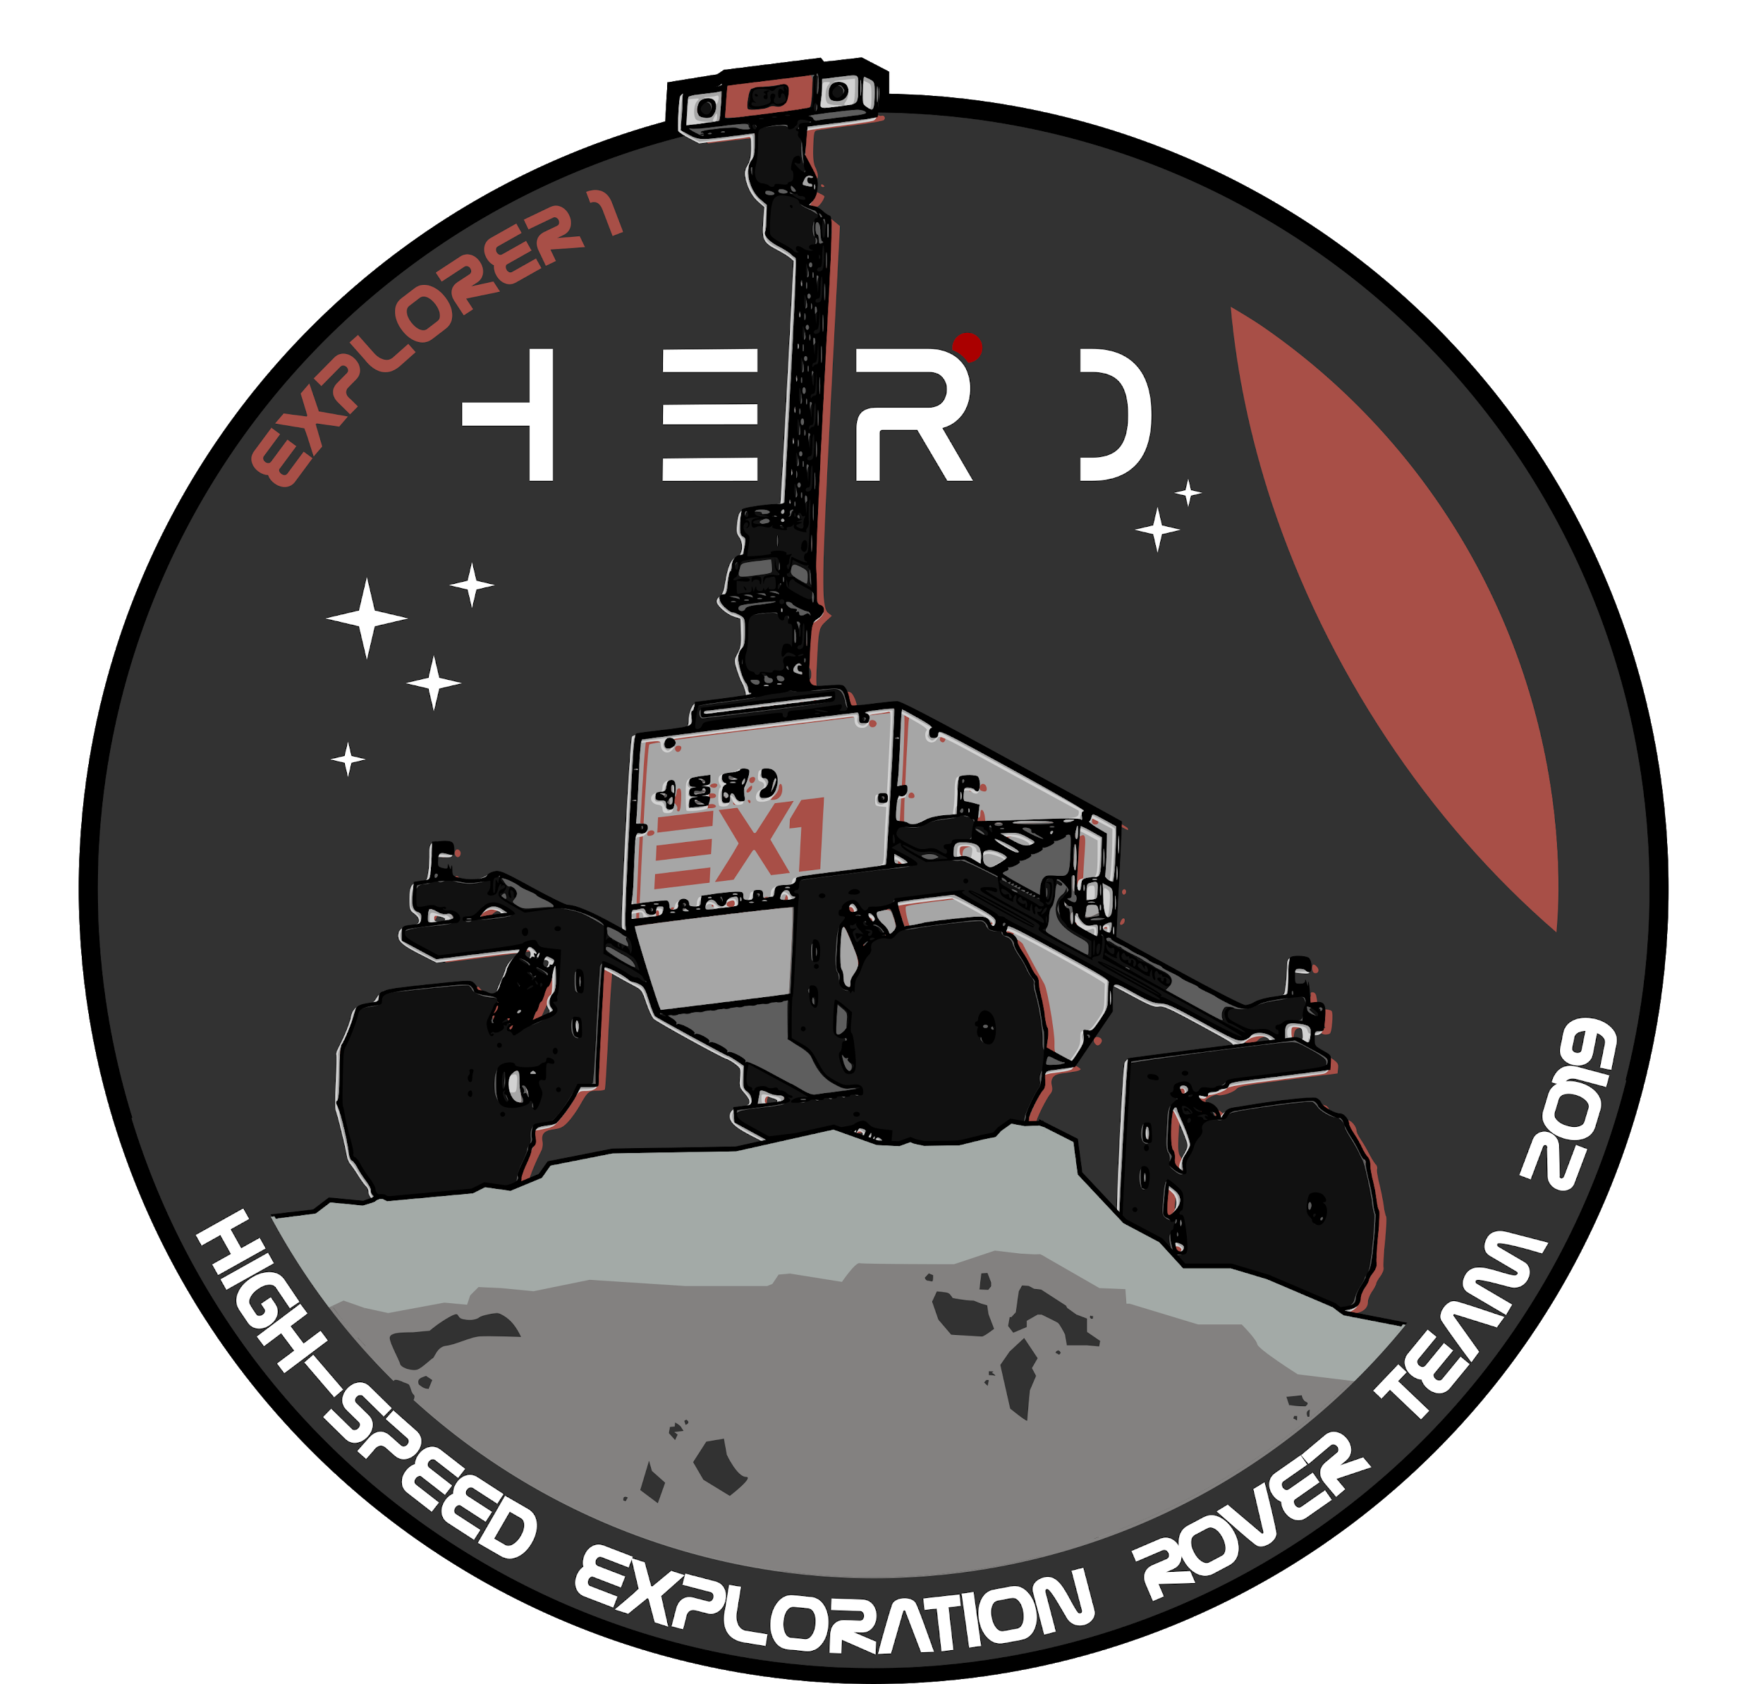

- User Manual -

|  |  |  |  |
| --- | --- | --- | --- |
| Created by: | David Rodriguez (davidrm@dc.tohoku.ac.jp) | Date: | 2020-02-05 |
| Issue : | 1 | Revision: | 0 |
| Last reviewed by: |  | Date: |  |

*Page left intentionally blank*

# 

# 

# 

# Table of Contents

**Table of Contents** **3**

**List of Acronyms** **6**

**List of Figures** **8**

**List of Tables** **9**

**Before you start.** **10**

Scope of this manual. 10

How to use this manual. 10

Files system organization. 11

**Rover vehicle overview.** **13**

Rover vehicle description. 13

Configuration overview. 14

**Mechanical design and configuration.** **16**

Rover chassis. 16

Locomotion system. 18

Navigation Mast (NAVMAST). 20

Service Module (SVM). 21

**Electronics and sensors.** **23**

Onboard computers. 23

Primary Onboard Computer (P-OBC) 23

Secondary Onboard Computer (S-OBC) 25

Actuated Drive Electronics (ADE). 25

Driving motor unit. 25

Steering motor unit. 25

Motor controller. 26

Motor driver. 26

Rocker Interface Unit (RIU) 26

Power connector 27

FTDI 27

Line receivers 27

Current sensing bridge 28

USB to debug 29

Prototyping header 29

Lights Control Board (LCB). 32

Inertial Measurement Unit (IMU). 33

**Power system design.** **35**

General architecture. 35

Power Supply Unit (PSU) 36

Power Distribution Unit (PDU) 39

**Software and data handling.** **40**

Overview. 40

Operating system. 40

Low-level software. 42

Motor control. 43

Encoder reading. 45

Position reading 45

Speed calculation 46

Handling over- and underflow 46

Automatic motor control. 46

Analog reading. 48

On-board data handling system. 49

**Communication system.** **50**

Overview. 50

Internal communication protocol. 51

UART driver. 51

Ring FIFO Buffer. 52

Packet architecture. 53

Dictionary of commands. 53

Cyclic Redundancy Check (CRC). 54

Consistent Overhead Byte Stuffing (COBS). 55

Automatically executed routines. 57

**How-to.** **59**

Power up the rover. 59

Start-up sequence. 60

Remote access to the P-OBC. 60

Important Information 60

Waking up EX1 61

Learning resources 62

Connecting a PS4 Dualshock controller to the P-OBC. 62

Preparation. 62

Installation 62

Connection 63

Option 1: Connecting via bluetooth. 63

Option 2: Connecting via USB. 63

Testing 63

Option 1: Without ROS 63

Option 2: With ROS 63

Reference. 64

DualShock PS4 Controller buttons and axes mapping 64

Troubleshooting 65

Running ds4drv without sudo permissions. 65

Check if linux recognize your PS4 controller 66

PS4 controller is not accessible for the ROS joy node 66

Ds4drv hidraw mode not detecting your controller 66

Accessing the P-OBC GPIO pins. 67

Basic information. 67

Quick testing of GPIO pins from userspace. 67

Sending data through P-OBC USB port using ROS serial library. 69

Preparation. 69

Operation 69

Mounting/dismounting chassis panels. 71

Low-Travel Suspension and wheel assembly process. 72

Wheel 72

Low-travel suspension 73

Integration on the chassis 73

EX1 Teleoperation 74

**Appendix A - Modifications Log.** **76**

**Appendix B - UART reading with Matlab.** **77**

**Appendix C - WARN & ERROR Reference.** **81**

ROS_WARN_STREAM 81

ROS_ERROR_STREAM 82

**Appendix D - Datasheets.** **83**

# 

# List of Acronyms

|  |  |
| --- | --- |
| 4WS | 4 Wheel Steering |
| ADE | Actuator Drive Electronics |
| ASC | Acceleration and Speed Control |
| ATC | Active Thermal Control |
| AWD | All Wheel Drive |
| CCW | Counterclockwise |
| C-PTU | Camera Pan and Tilt Unit |
| CW | Clockwise |
| DAC | Driving Action Control |
| EMO | Emergency Off |
| EX1 | Explorer 1 |
| GCS | Ground Control Station |
| HTS | High-Travel Suspension |
| IMU | Inertial Measurement Unit |
| LCB | Lights Control Board |
| LSB | Least Significant Byte |
| LTS | Low-Travel Suspension |
| L-TU | LIDAR Tilt Unit |
| MHS | Mechanically-Hybrid Suspension |
| NavCam | Navigation Camera |
| NAVMAST | Navigation Mast |
| PCDE | Power Conditioning and Distribution Electronics |
| PDU | Power Distribution Unit |
| P-OBC | Primary Onboard Computer |
| PSU | Power Supply Unit |
| PTC | Passive Thermal Control |
| PV | Photovoltaic |
| PWM | Pulse Width Modulation |
| RIU | Rocker Interface Unit |
| SAC | Steering Action Control |
| S-OBC | Secondary Onboard Computer |
| SVM | Service Module |

# List of Figures

***Fig. 1-1****. Explorer 1systems and subsystems architecture.*

***Fig. 1-2****. Explorer 1standard configuration*

***Fig. 3-1****. EX1 deployed configuration top and side views*

***Fig. 3-2****. EX1 deployed configuration front and rear views.*

***Fig. 3-3****. EX1 mechanically-hybrid suspension design.*

***Fig. 3-4.*** *Low-Travel Suspension (LTS) design.*

***Fig. 3-5.*** *Navigation Mast (NAVMAST).*

***Fig. 3-6****. Service Module (SVM).*

***Fig.4-1****. NVIDIA Jetson TX2.*

***Fig. 4-2.*** *NVIDIA Jetson Nano.*

***Fig. 4-3.*** *Hibot (a) motor controller and (b) motor driver units.*

***Fig. 4-4.*** *3D view of the Rocker Interface Unit (RIU).*

***Fig. 4-5.*** *Top view and individual connectors of the Rocker Interface Unit (RIU).*

***Fig. 4-6.*** *Schematic of the current sensing bridge built into the RIU.*

***Fig. 4-7.*** *Connectivity diagram for half of the Rocker Interface Unit (RIU), i.e., all the modules for one single rocker.*

***Fig. 4-8****. Schematic of the Lights Control Board (LCB) circit.*

***Fig. 4-9.*** *Lights Control Board (LCB).*

***Fig. 4-10.*** *IMU sensor module.*

***Fig. 5-1****. EX1 power system architecture.*

***Fig. 5-2.*** *Power Supply Unit (PSU).*

***Fig. 5-3.*** *Power Distribution Unit (PDU) 3D and top views.*

***Fig. 6-1.*** *ROS node graph of the central OS.*

***Fig. 6-2.*** *Working principle of an H-bridge.*

***Fig. 6-3.*** *Different command signals applied to the H-bridge and their effect.*

***Fig. 6-4****. Speed control with consecutive step commands for two different frequencies of operation.*

***Fig. 6-5****. Position control with consecutive step commands for two different frequencies of operation.*

***Fig. 6-6.*** *Overview of the high-level functions implemented in the low-level software.*

***Fig. 7-1.*** *Simplified communication system architecture.*

***Fig. 7-2.*** *How a FIFO ring works.*

***Fig. 8-1.*** *Reference image of EX1 back panel.*

***Fig. 8-2.*** *Fake screw sign.*

***Fig. 8-3.*** *EX1 wheel exploded view.*

***Fig. 8-4.*** *EX1 Low-travel suspension (LTS) exploded view.*

***Fig. 8-5.*** *EX1 joystick reference for teleoperation.*

# List of Tables

***Table 4-1.*** *NVIDIA Jetson TX2 and NVIDIA Jetson Nano general characteristics .*

***Table 4-2****. Pinout reference for the microcontroller.*

***Table 4-3****. Description of connectors in the Lights Control Board (LCB).*

***Table 5-1****. Mini-box DCDC-USB converter specifications.*

***Table 5-2****. Cosel MGFS302412 DC-DC converter specifications.*

***Table 5-3****. Cosel MGFS302405 DC-DC converter specifications.*

***Table 6-1****. Truth table of the H-bridge.*

***Table 7-1****. UART communication settings.*

***Table 7-2****. EX1 internal communication protocol packet description.*

***Table 7-3****. Commands sent by the P-OBC.*

***Table 7-4****. Data sent to the P-OBC.*

***Table 7-5****. Generation settings of the CRC used.*

***Table 7-6****. Example of COBS stuffing steps.*

***Table 7-7****. Example of COBS unstuffing steps.*

***Table 7-8****. Stuffed size of each command and data transmitted.*

***Table 7-9****. Automatically executed tasks and their execution time.*

***Table 8-1.*** *Index number of joy.buttons.*

***Table 8-2.*** *Index number of joy.axes.*

***Table 8-3****. P-OBC GPIO reference for controlling the lights.*

# 

# Before you start.

Explorer 1 (EX1) is the first prototype of the family of planetary exploration robots developed by the High-speed Exploration ROver (HERO) Team, a research group founded at the Space Robotics Laboratory of Tohoku University in April, 2018. HERO was founded as a result of a memorandum of collaboration with the European Space Agency (ESA).

The main research topic driving this collaboration is **the study, development, and application of innovative ground mobility systems for fast lunar prospection**. Such a research statement encompasses a wide range of subtopics in the areas of guidance, navigation, and locomotion of wheeled robots. As a baseline, all of our studies consider **ground speeds that approach or surpass 1 m/s**; i.e., speeds that are two orders of magnitude greater than currently conceived operational velocities for lunar and martian exploration robots. This speed requirement has tremendous implications in the design and operability of future planetary robots.

EX1 was designed with the intention to serve Space Robotics Lab’s members, from all different research groups, for the years to come. Systems have been specifically chosen and adapted for this purpose.

## Scope of this manual.

This manual presents a full description of the EX1 rover and its different subsystems. This manual is intended for those students planning on upgrading one or several of the rover subsystems, those intending on using the rover for their own research, or to help those simply interested in learning about the platform and its development process.

The different rover systems and subsystems are described in detail in the following pages. A description of how to assemble, disassemble and/or modify any of the subsystems are given when considered necessary (see Chapter 8). Depictions of the mechanical system are included for clarity purposes. Schematics of electrical and electronic systems are also included as a reference alongside code snippets when considered appropriate. Students are strongly advised to familiarize themselves with this information before attempting to manipulate or make use of the platform in any way.

## How to use this manual.

The present manual was written in a way that considers each chapter independent of the others. For the most part, this means that each chapter is self-sufficient and provides specific information pertaining, in most cases, to one rover system. Students are encouraged to skip sections of this manual as they see fit.

If this is your first time reading this manual, keep reading. You will find relevant information that you most likely need to learn in the following pages.

If you are already familiar with the platform, the **outline on page 3** will become your best tool to find the information you need.

Any change, modification, or adjustment performed to any of the systems and/or subsystems of the rover, including modifications at the software level or alterations in the file system organization, should be properly logged and documented in this manual. Three basic actions are required.

1. The basic information related to the modification has to be logged into *Appendix A - Modifications Log* of this manual. This helps future students understand what progress the rover has endured over the years and what the current state of the platform is.
2. Detailed information should then be included in the appropriate chapter or section of this manual.
3. Last, a **new revision** of this manual should be produced if the alteration(s) performed affects any of the rover subsystems, including minor changes (e.g. telemetry rosbags were moved to a new directory). A **new issue** of this manual should only be produced if the alteration(s) involves major changes to rover systems (e.g. plastic wheel knuckles were substituted by aluminum ones).

## Files system organization.

This manual is part of a large archive of files containing all the relevant information related to the EX1 rover and the HERO group. All these files are stored in the HERO Team workspace in Bitbucket (<https://bitbucket.org/hero_team/>). A number of repositories are available in this workspace.

* *h*[*ero_ex1_sw*](https://bitbucket.org/hero_team/hero_ex1_sw): This repository contains the high-level control system and full catkin workspace required to run the EX1 rover Primary Computer (P-OBC).
* [*3_ex1_hibot_sandbox*](https://bitbucket.org/hero_team/3_ex1_hibot_sandbox): A sandbox used to experiment with HiBot M4 cortex microcontrollers, HiBot DC motor drivers and automatic control. It also includes the low-level control software.
* *ex1_service_module*: Design files for the PCBs of the Power Supply Unit (PSU), the Power Distribution Unit (PDU) and the Rocker Interface Unit (RIU).
* [*ex1_navmast*](https://bitbucket.org/hero_team/ex1_navmast): This repository contains software related to the Navmast (Navigation Mast) currently running on EX1 Secondary Computer (S-OBC).
* *ex1_manufacturing*: Files related to the manufacturing process of EX1. Includes components datasheets and purchasing orders.
* *ex1_vrep*: It contains EX1 dynamic module and simulation scenes.
* *ex1_testing*:
* *ex1_user_manual*:
* *ex1_other_files*: This repository includes team logos, old meeting files, and reference files to papers, old theses, and team presentations.
* *ex1_cad_files*: A backup of all the CAD files.
* [*hsctestbed*](https://bitbucket.org/hero_team/hsctestbed): This repository contains software files required to operate the High-Speed Circular Testbed (HSCT) currently available in Room 410, M1 Building, Aobayama Campus.

The last version of all the CAD files related to EX1 can be found in the team’s grabCAD workbench. If you are a new lab member without access to the team’s workspace and workbench, ask the person in charge (currently: David Rodriguez, [davidrm@dc.tohoku.ac.jp](mailto:davidrm@dc.tohoku.ac.jp)).

# Rover vehicle overview.

## Rover vehicle description.

Explorer 1 (EX1) is a 4-wheel robot designed with a AWD/4WS (All Wheel Drive/4 Wheel Steering) configuration. EX1 was designed based off ElDorado 2 platform in order to reduce development costs. ElDorado 2 was an old rover platform that was inoperative at the time. The parts inherited from ElDorado 2 included: steering motors, 3-gear differentials, chassis frame, bottom body panel, and both rocker arms.

The current version of the EX1 rover supports functions that allow the rover to be **teleoperated at an ample range of speeds**, with a **maximum operational speed of 1 m/s**. The prototyping character of EX1, for which about 50% of mechanical parts were made out of 3D-printed ABS, implies that extreme operational conditions, such as long drives at maximum speed or the negotiation of large obstacles at increased speed, should be avoided or exceptionally attempted. EX1 design supports the implementation of autonomous capabilities, which can be developed by future students without the need to expand the current rover sensor suite or to remodel the rover systems architecture. The rover in its current state is capable of providing the following functions:

* Power storage, regulation, and distribution.
* Data processing and storage.
* Communication to user/pilot through the Ground Control Station (GCS).
* Teleoperation of the main locomotive functions:
  + Forward and backward driving at speeds in the range of 0.1-1 m/s.
  + 2-wheel front steering while driving at speeds in the range of 0.1-1 m/s.
  + Fixed-speed point-turn steering mode. Speed currently set at 0.2 m/s.

In order to provide this set of functions, the rover is structured around a number of systems and subsystems as illustrated in the following figure:

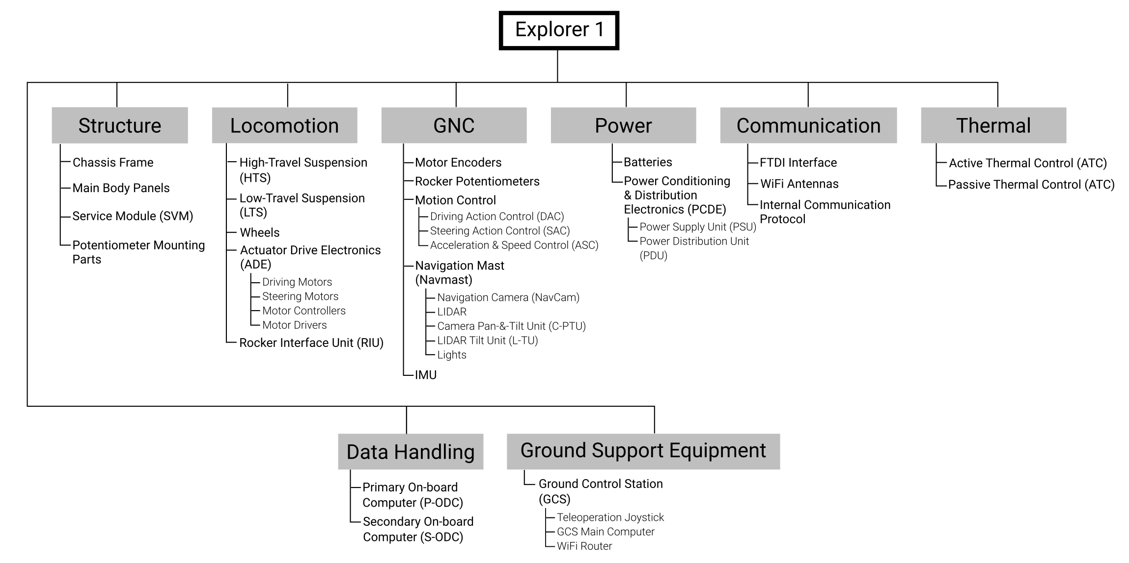

***Fig. 1-1****. Explorer 1systems and subsystems architecture.*

## Configuration overview.

EX1 simplified configuration is based on a cuboidal chassis on which the majority of the rover subsystems are mounted. The suspension subsystem is divided into a high-travel, conventional suspension—i.e., passive rocker arms connected by 3-gear differentials—and a low-travel, elastic suspension. This new mechanically hybrid suspension or MHS design is what provides the rover its efficient high-speed capability.

A navigation mast referred to as NAVMAST was included in the design despite not being necessary for basic, visual-based teleoperation[1]. The navmast was included in the design with the intention that future students could increase the rover autonomous capabilities. Vital electronics are accommodated and protected from the environment inside the main body. The electronics and harnessing of EX1 are integrated on a mounting plate designed with the objective of facilitating maintenance and troubleshooting. This mounting plate can be extracted from the main body (details are provided in Section 3.4.). A light system that includes a pair of lights on top of the navmast and a LED bar attached to the main body was included to allow for low-visibility tests to be conducted in the future.

Several of the rover subsystems are identified in the figure below. Details of each system and subsystem are provided in the following sections.

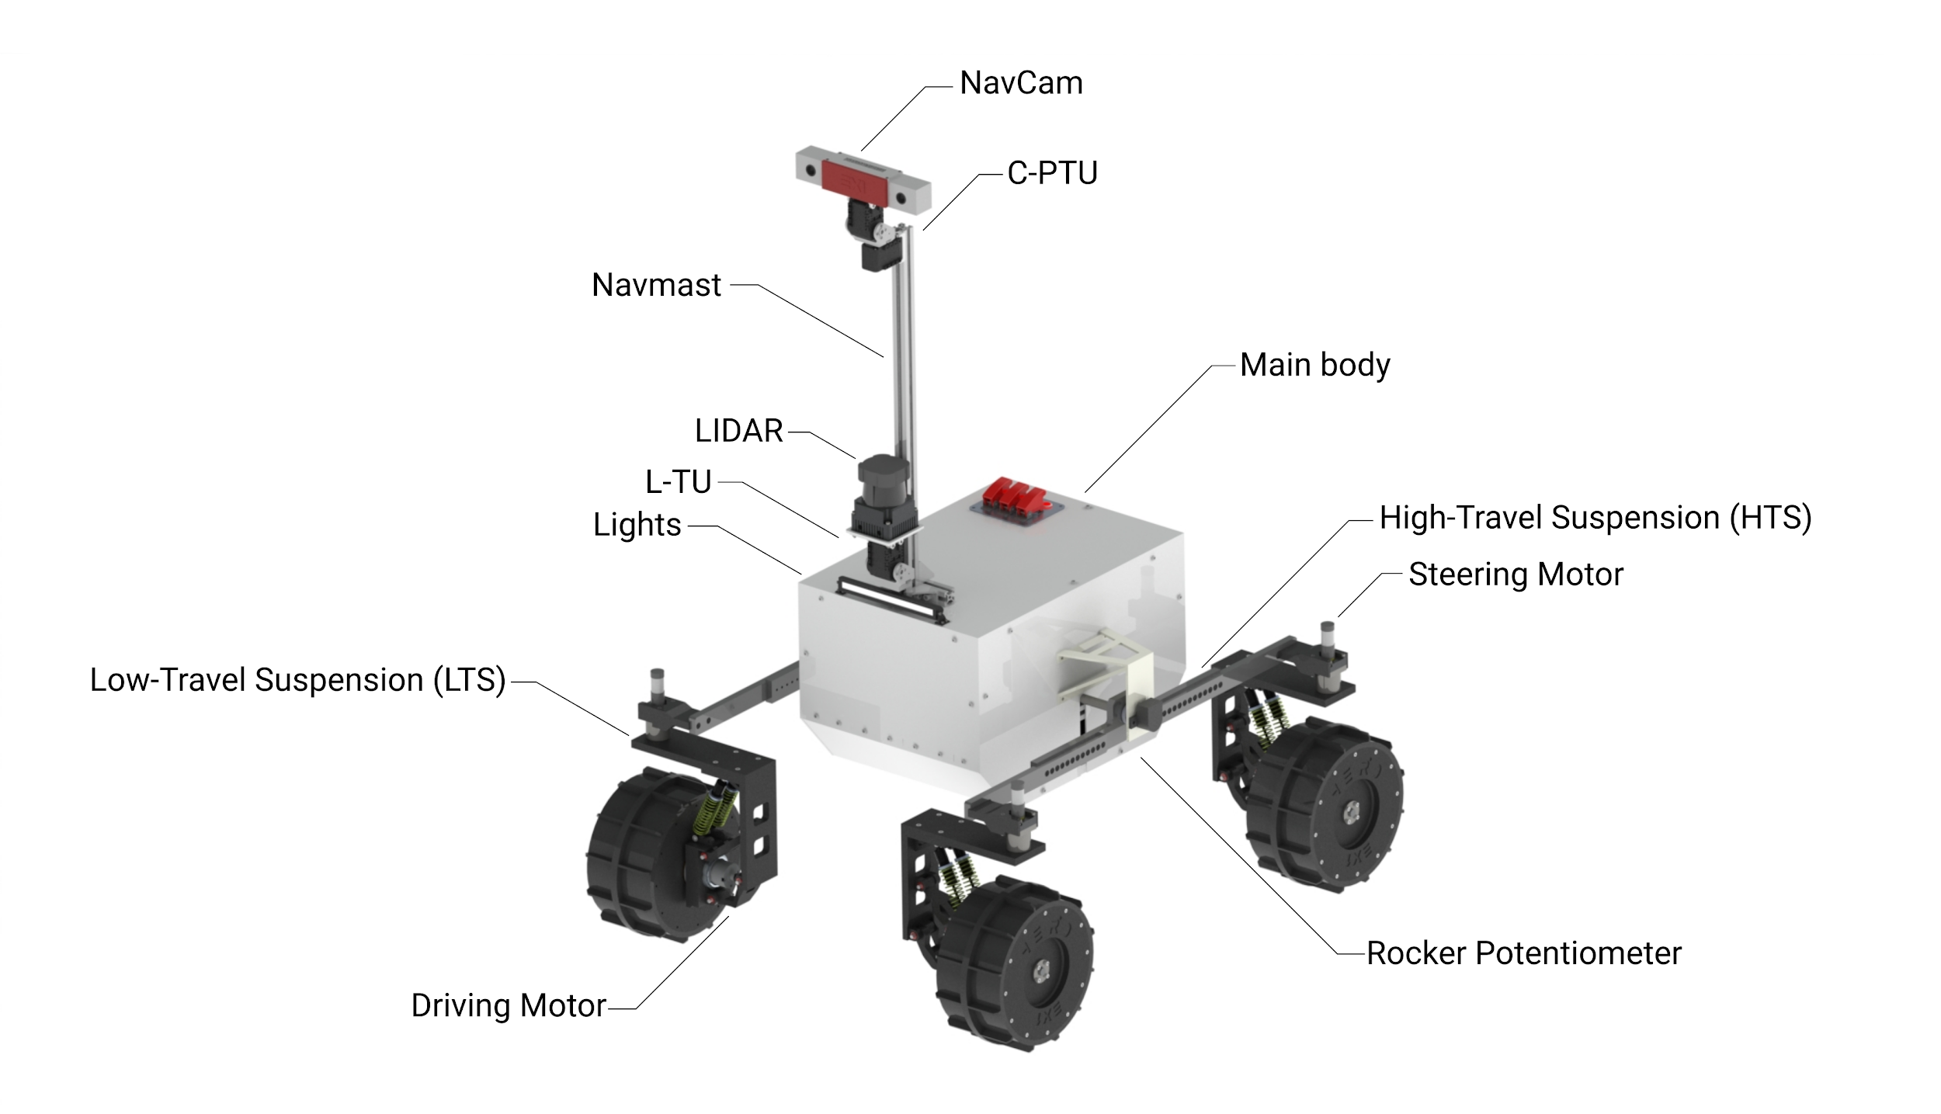

***Fig. 1-2****. Explorer 1standard configuration.*

# Mechanical design and configuration.

## Rover chassis.

The rover main body consists of a cuboidal aluminum frame chassis inherited from the old ElDorado 2 platform. Unlike in the old rover, to the chassis is now mounted 2 mm-thick white acrylic panels that, alongside the chassis frame, provide accommodation, protection, and mechanical support for the majority of systems and subsystems. These panels enclosed the Service Module (SVM, see Section 3.4.)—a MDF wood board attached to the chassis in which all the electronics are mounted. The SVM also provides mechanical accommodation for the wire harness of the rover and facilitates maintenance and troubleshooting of the electronics due to its simple extraction method.

Attached to the top panel are the Navigation Mast (NAVMAST), the battery connectors, and an Emergency Off (EMO) switch, which should be engaged at all times when the robot is not being operated. The NAVMAST includes the Camera Pan & Tilt Unit (C-PTU) and the LIDAR Tilt Unit (L-TU), two mechanisms that increase the dexterity and potential for autonomy of EX1. These mechanisms are controlled by the Secondary On-Board Computer (S-OBC). Further information on the NAVMAST is provided in Section 3.3.. The location for the batteries was chosen to counteract the negative effects of an otherwise poorly balanced gearbox. Batteries were positioned so as to bring the center of mass of the rover as close as possible to the geometric center of the chassis. To the sides of the main chassis two rocker potentiometers are mounted via a couple of 3D-printed ABS parts. This mounting system was inherited from the old ElDorado2 platform. Attached to the back panel are the P-OBC WiFi antennas and two toggle switches that allow power to flow through the lines of the P-OBC and both driving and steering motors.

In its current state, EX1 only supports a fully-deployed configuration mode. However, the design is easily adaptable to also include a stowed configuration if required by future projects (e.g., to ease transportability) provided that four extra motors (“deployment motors”) are incorporated into the design at the interface between the High-Travel and Low-Travel Suspension (HTS and LTS, respectively). No energy generation devices were incorporated into the design. In the future, a photovoltaic (PV) solar module can be attached to the top panel either by avoiding the batteries or by relocating them to a different part of the rover. As previously mentioned, EX1 incorporates a set of lights for low-visibility testing that includes a pair of LED sets attached to the Optical Bench of the NAVMAST and a LED bar mounted on the chassis front panel. These lights are controlled from the teleoperation joystick of the P-OBC and their brightness can be independently modified through the Lights Control Board (LCB) inside the SVM (see Section 4.4. for further information).

Layout drawings of the rover and its key dimensions are displayed in Fig. 3-1 and 3-2.

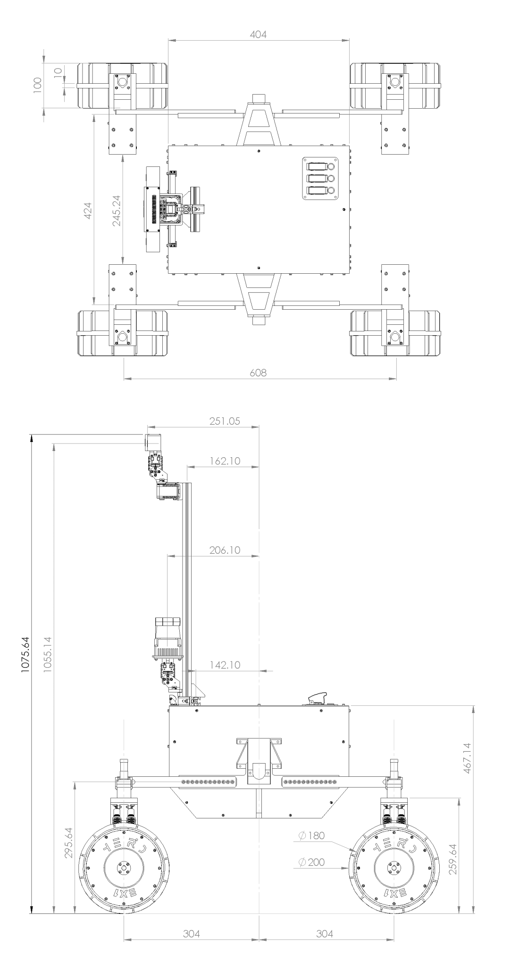

***Fig. 3-1****. EX1 deployed configuration top and side views*

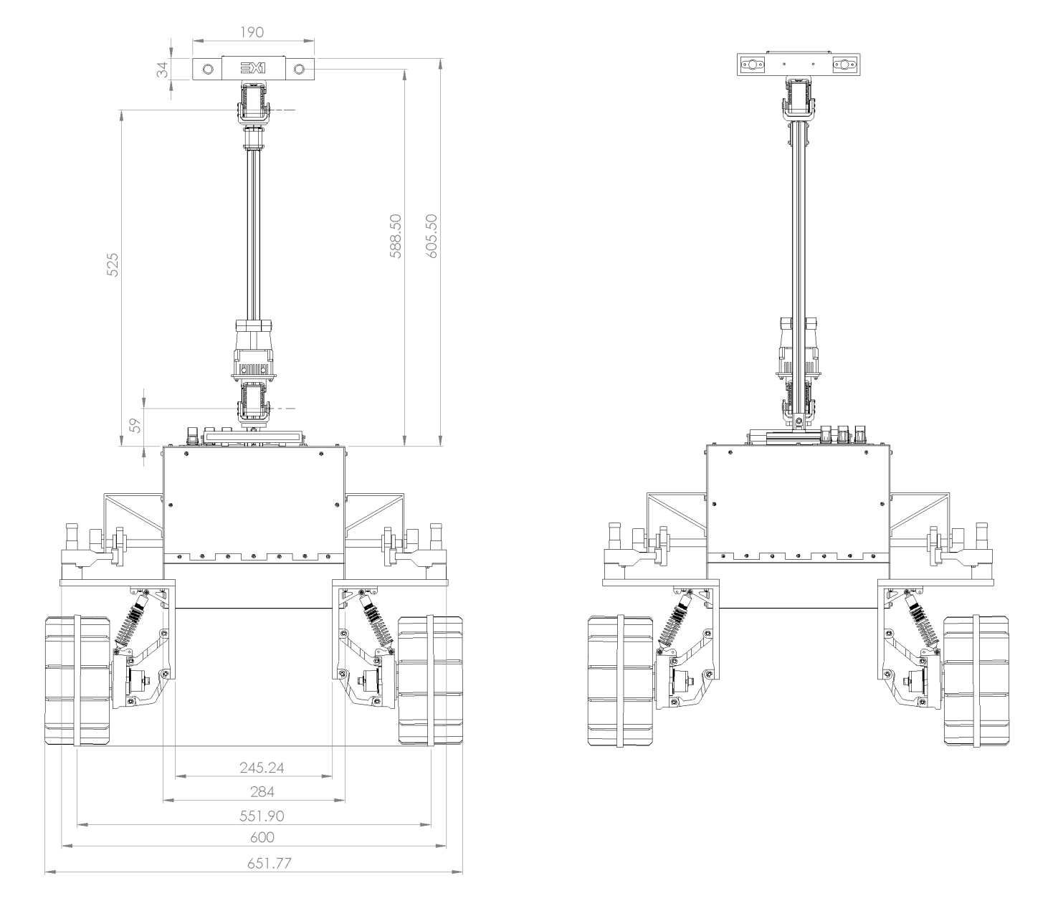 ***Fig. 3-2****. EX1 deployed configuration front and rear views.*

## Locomotion system.

EX1 locomotion system consists of an innovative mechanically-hybrid suspension (MHS) system attached to the input shafts of two 3-gear differential boxes housed inside the rover chassis. A depiction of the suspension is shown in Fig. 3-3. As the name suggests, the suspension is formed by two mechanical parts that work in unison: a high-travel, rigid suspension (HTS) coupled to a low-travel, elastic suspension (LTS). The combination of both the rigid suspension mode of the HTS and the elastic mode of the LTS is what allows the rover to withstand the impact loads and vibrations resulting from high-speed driving while being able to overcome individual obstacles of sizes comparable to the rover wheel size. The HTS has a travel range of 250 mm only limited by the length of the wire harness of the Actuator Drive Electronics (ADE) (for information on the ADE refer to Section 4.2.). The LTS has a maximum travel range of 35 mm, limited by the maximum travel range of the dampers.

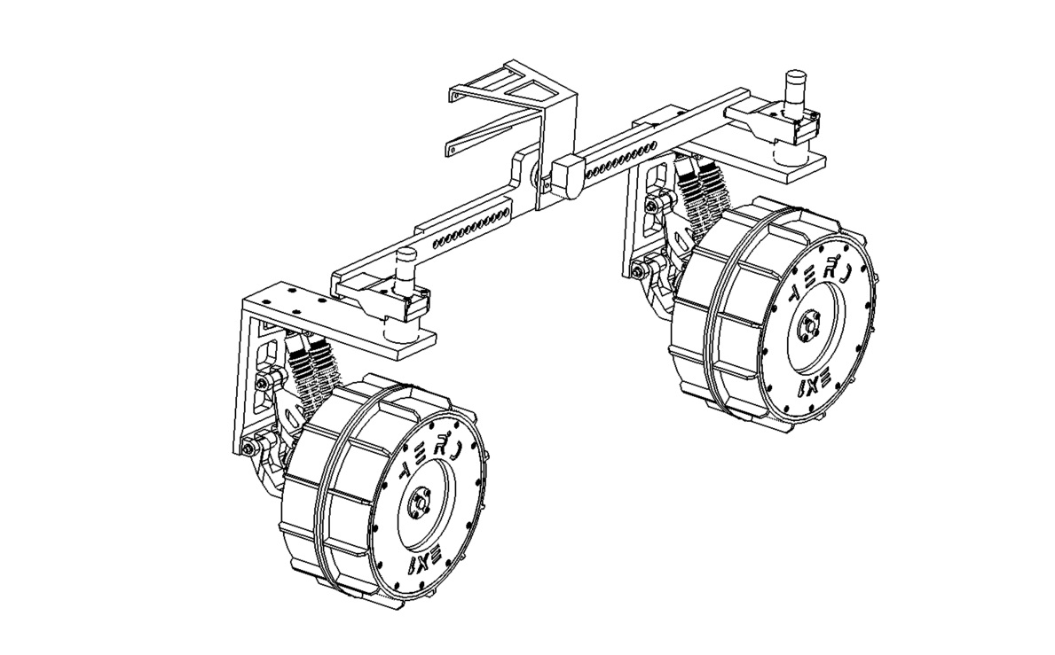

***Fig. 3-3****. EX1 mechanically-hybrid suspension design.*

The HTS is nothing else but a pair of free-balancing arms, called rockers, directly attached to the shaft of the differential at one end—to keep the main body on a steady position at all times—and to the LTS at the other end. The steering motor acts as the connecting piece between the HTS rocker arms and the LTS bracket. This allows the LTS to rotate with the wheel when the steering motors are actuated. The LTS consists of a 3D-printed bracket, where the head of the shock absorbers and the lower and upper control arms of the suspension are mounted, a pair of shock absorbers, formed by a replaceable spring and an adjustable damper, and the wheel knuckle, which connects to the driving motor housing and where the tail end of the shock absorbers are mounted. Both the bracket and the wheel knuckle present multiple mounting points on which the shock absorbers can be attached. The overall stiffness of the LTS can be slightly tweak by varying the orientation in which the shocks are mounted without having to completely replace the springs and/or the damper oil. A depiction of the LTS and its components can be seen in Fig. 3-4. For information on how to assemble and disassemble the suspension together with a more in-depth look into all the different parts refer to Section 8.7..

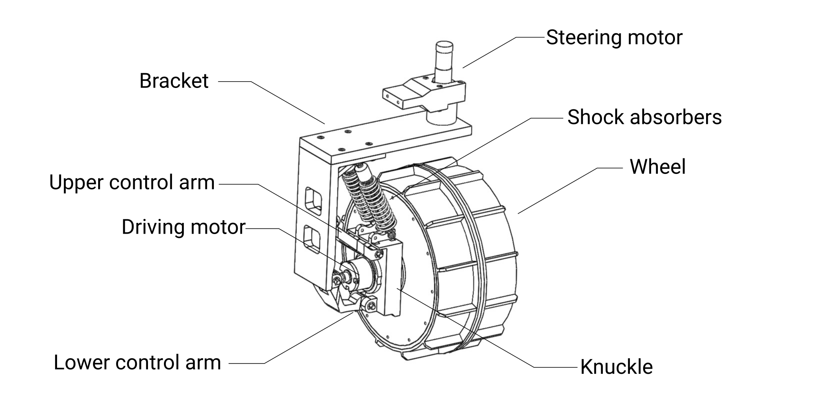

***Fig. 3-4.*** *Low-Travel Suspension (LTS) design.*

## Navigation Mast (NAVMAST).

The NAVMAST consists of an aluminum extrusion frame of length 600 mm fixed to the top panel of the chassis by a pair of M4x15 screws attached to post-assembly insertion nuts. Attached to the frame are the LIDAR Tilt Unit (L-TU) and the Camera Pan & Tilt Unit (C-PTU). The L-TU is a simple tilting mechanism composed of a **Dynamixel AX-12A servo motor** that controls the movement of a **Hokuyo UTM-30LX Scanning Laser Rangefinder**. The C-PTU is also conformed by two Dynamixel AX-12A that provide the pan and tilt motion to the Optical Bench. The Optical bench is a 3D-printed case enclosing an **Intel Realsense D435 camera**, hereinafter referred to as Navigation Camera or NavCam, and two sets of LED lights. A camera protective cover is attached to the Optical Bench by four 4 mm neodymium magnets.

The vertical position of both the NavCam and the LIDAR can be adjusted. In order to facilitate the transportation of the rover, the NAVMAST can be easily detached from the top panel by first removing the front chassis panel and loosening the screws that hold it on top.

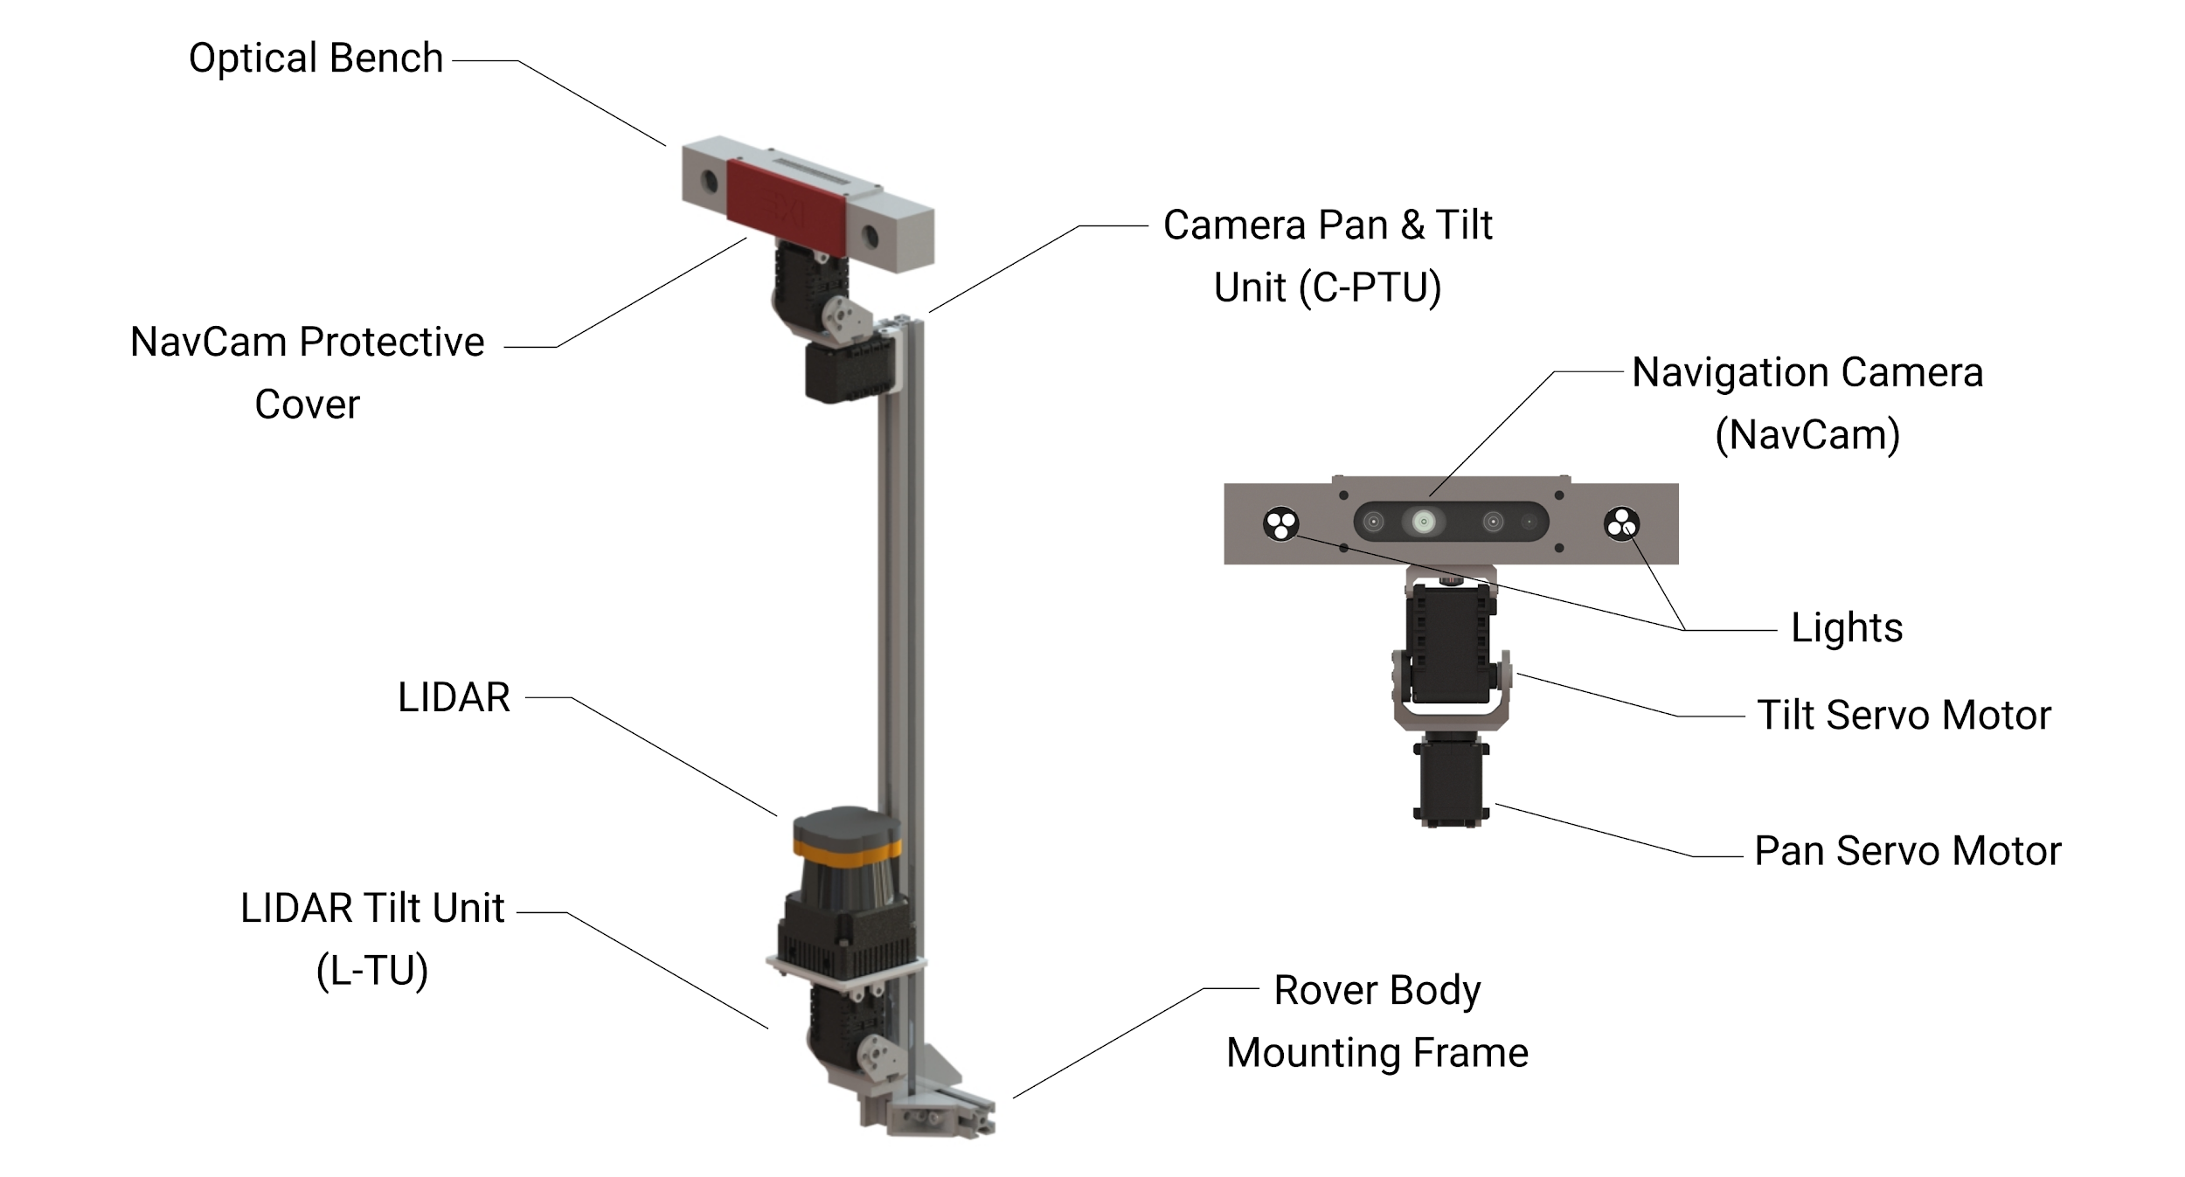

***Fig. 3-5.*** *Navigation Mast (NAVMAST).*

## Service Module (SVM).

All the equipment housed within the rover body is mounted onto a MDF wood board referred to as the Service Module or SVM. This module provides mechanical support to the main stack of electronics of the rover, which includes: the Power Conditioning & Distribution Electronics (PCDE)—formed by the Power Supply Unit (PSU) and the Power Distribution Unit (PDU)—the Rocker Interface Unit (RIU) part of the ADE, the Inertial Measurement Unit (IMU), and the P-OBC. At the same time, the SVM helps arrange the wire harness, facilitating maintenance and troubleshooting. A footprint for the attachment of the S-OBC was included in the design of the SVM and can be found underneath the Lights Control Board (LCB). Additionally, the LCB was designed so that in the future it could be mounted on top of the S-OBC. The underside of the panel has been left free of components. Future projects can make use of the available space underneath the SVM. However, it should be kept in mind that the SVM is only accessible from the upper surface when the side panels of the chassis are mounted.

The SVM is suspended from the chassis by 8 pieces of polyethylene foam and held by two M4x40 screws on the front and rear side. The SVM was designed in such a way that, after all the external connections have been disconnected (see Section 8.6. for chassis panels disassembly instructions), the entire stack of electronics, including the wire harness, can be pulled out of the chassis facilitating maintenance and repair tasks. As will be described in Section 4.3., electrical connections between individual components outside the SVM have been minimized for this purpose. See Fig. 3-6 for an overview of the systems mounted on the SVM.

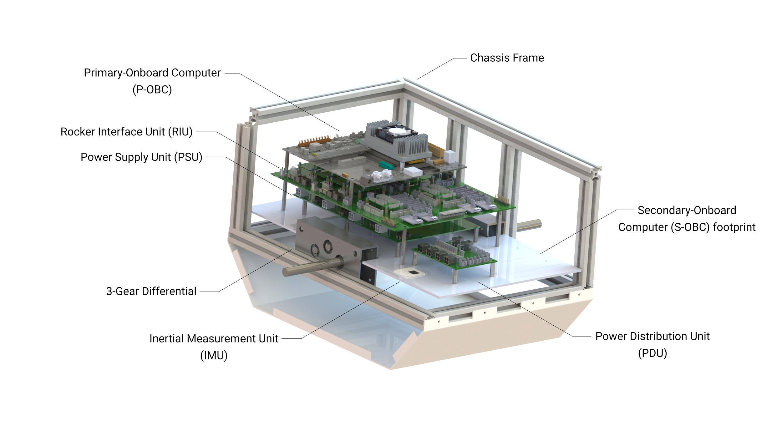

***Fig. 3-6****. Service Module (SVM).*

# Electronics and sensors.

## Onboard computers.

The EX1 rover embedded system in its current configuration makes use of two onboard computers so as to minimize computing load and facilitate the parallelization of tasks during development.

### Primary Onboard Computer (P-OBC)

As the name suggests, the P-OBC is the main computer in charge of all the high-level functionality of the rover. It consists of an **NVIDIA Jetson TX2 Development Kit** (see Fig. 4-1). The P-OBC is the most powerful of the two computers onboard. Additionally, all the incoming telemetry data from proprioceptive sensors is received by and stored in the P-OBC. The rover functionality handled by the P-OBC includes:

* Communication with Ground Control Station (GCS) to retrieve orders.
* High-level to low-level communication of main locomotive tasks (i.e., driving and steering).
* Communication with the ADE to receive telemetry data.
* Storage of telemetry data.

The P-OBC was slightly modified so as to activate Auto-Power-ON mode, i.e., a mode that allows the P-OBC to turn ON when VCC is detected.

The P-OBC was initially flashed using **JetPack 4.3 SDK**[2]. Currently, a linux for tegra (L4T) operating system running **Ubuntu 18.04 LTS** is used in the P-OBC. General specifications of the P-OBC can be found in Table 4-1.

Future students can decide whether to use the P-OBC for additional tasks related to increasing the autonomous capabilities of the rover; examples of these tasks include the reception and manipulation of incoming data from the NavCam and/or the LIDAR. Nonetheless, to facilitate this task a secondary computer was included in the design.

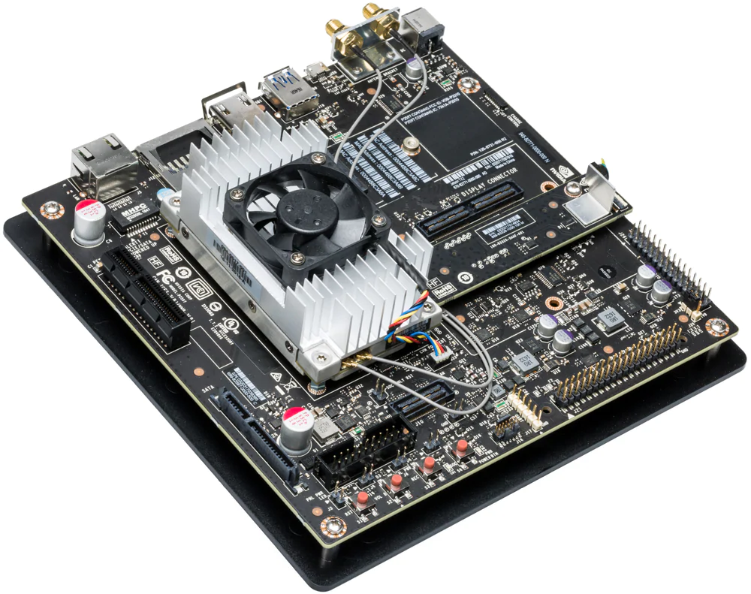

***Fig.4-1****. NVIDIA Jetson TX2.*

***Table 4-1.*** *NVIDIA Jetson TX2 and NVIDIA Jetson Nano general characteristics.*

|  |  |  |
| --- | --- | --- |
| Specs | Jetson TX2 (P-OBC) | Jetson Nano (S-OBC) |
| CPU | ARM Cortex-A57 (quad-core) @ 2GHz +  NVIDIA Denver2 (dual-core) @ 2GHz | 64-bit Quad-core ARM A57 @ 1.43GHz |
| GPU | 256-core Pascal @ 1300MHz | 128-core NVIDIA Maxwell @ 921MHz |
| Memory | 8GB 128-bit LPDDR4 @ 1866Mhz | 59.7 GB/s | 4GB 64-bit LPDDR4 @ 1600MHz | 25.6 GB/s |
| Storage | 32GB eMMC 5.1 | MicroSD card (16GB UHS-1 recommended minimum) |
| Wireless | 802.11a/b/g/n/ac 2×2 867Mbps | Bluetooth 4.1 | M.2 Key-E with PCIe x1 |
| Ethernet | 10/100/1000 BASE-T Ethernet | Gigabit Ethernet (RJ45) |
| USB | USB 3.0 + USB 2.0 | 4x USB 3.0 A (Host) | USB 2.0 Micro B (Device) |
| Misc I/O | UART, SPI, I2C, I2S, GPIOs | UART, SPI, I2C, I2S, GPIOs |
| Dimension | 17 x 17 cm | 10 x 8 cm |
| Temp. Range * | -20º/ 80ºC | -20º/ 80ºC |
| Power** | 7.5 W | 10 W |

*Operating temperature range, TTP max junction temperature.

**Typical power consumption under load, input 5.5-19.6 VDC.

### Secondary Onboard Computer (S-OBC)

As previously mentioned, a secondary computer was included in the design. This decision was made with the objective of minimizing the number of tasks handled by the P-OBC while parallelizing heavy computational tasks often associated with the manipulation of visual data. Overall this will result in faster computational times, a much-needed capability for high-speed, autonomous navigation.

In EX1 current configuration, the S-OBC is in charge of the manipulation of the L-TU and C-PTU as well as the reception and storage of both LIDAR and NavCam data. At the moment of writing, the S-OCB is still pending to be integrated into the final EX1 assembly. The general characteristics of the S-OCB can be found in Table 4-1.

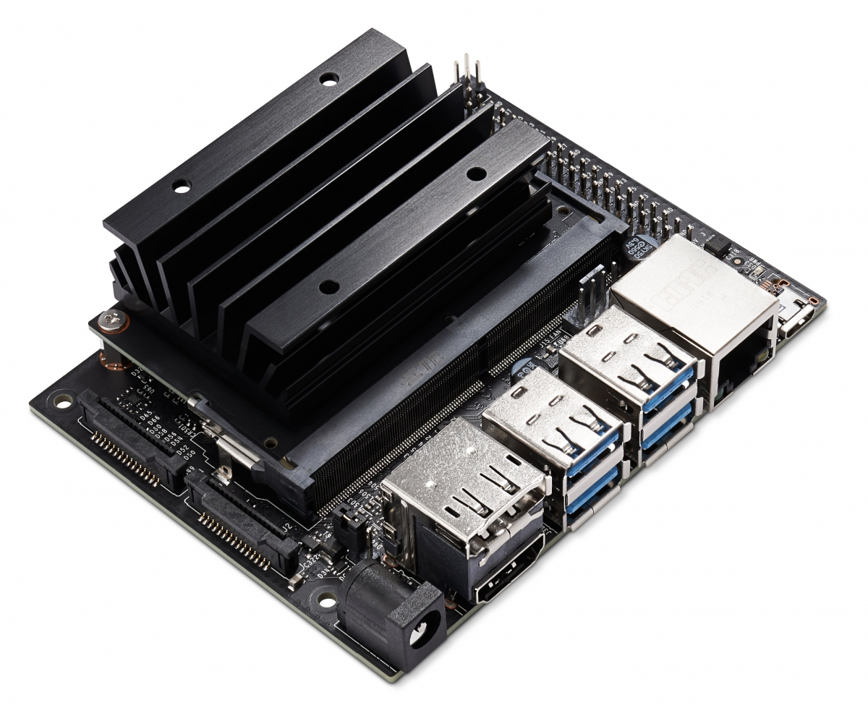

***Fig. 4-2.*** *NVIDIA Jetson Nano.*

## Actuated Drive Electronics (ADE).

The ADE is composed of all the different modules in charge of the control and actuation of the rover mechanisms (i.e., driving and steering motors). The respective datasheet of each module can be found in Appendix D - Datasheets.

### Driving motor unit.

EX1 wheels are independently actuated by **Maxon© DCX32L GB KL 36V, ⌀32mm, 70W** motors. Each motor mounts a **Maxon© GPX32HP 62:1** planetary gearhead and a **Maxon© ENX10 EASY 1024IMP** embedded quadrature encoder.

### Steering motor unit.

EX1 wheels are also independently steered by Maxon© **RE-Max 17 GB, ⌀17mm, 4.5W** motors (part number 216013). Each motor mounts a **Maxon© GP16A ⌀17mm, 5.4:1** planetary gearhead (part number 118184) fixed to a secondary 100:1 gear interface providing a **total reduction ratio of 540:1**. Additionally a **Maxon© MR Type M 128-512 CPT, ⅔ Channels** embedded quadrature encoder (part number 201940) is built in each motor.

### Motor controller.

The motor controllers consist of a programmable **Hibot Titech M4 development board**, which makes use of an **ARM M4 cortex-based microcontroller (STM32F407IG)**. These microcontrollers are used as the low-level interface between the P-OBC and the different units comprising the locomotion system (i.e. motor drivers, motors, and sensors). One motor controller per rocker is used. This means that 4 motors (2 driving motors and 2 steering motors) and each respective driver are controlled by one single microcontroller. An image of the motor controller used is shown in Fig. 4-3(a).

### Motor driver.

Each individual driving and steering motor makes use of a **Hibot UM 1XH DC motor driver.** These motor drivers consists of a full H-bridge without a charge pump and are controlled via two external Pulse Width Modulation (PWM) signals. An image of the motor driver used is shown in Fig. 4-3(b).

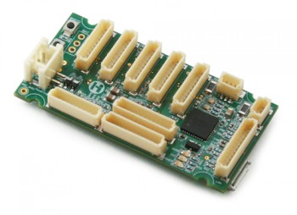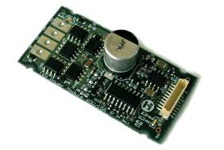

*(a) (b)*

***Fig. 4-3.*** *Hibot (a) motor controller and (b) motor driver units.*

## Rocker Interface Unit (RIU)

The Rocker Interface Unit (RIU) is a large PCB in which the individual control units of the ADE (i.e., motor controllers and drivers) for both rockers are integrated alongside other modules required for connectivity, data communication, and data stabilization. Each rocker consists of one potentiometer (to measure the rocker angle), 2 steering motors and 2 driving motors with their respective controller, drivers, and encoders. The RIU receives power for each component of the ADE directly from the Power Distribution Unit (PDU)(for details on the Power System refer to Chapter 5 of this manual). Rocker potentiometers, driving and steering motors, motor controllers, motor drivers, and encoders for both rockers are all assembled directly into the RIU. A 3D view and a top view of the RIU can be seen in Fig.4-4 and Fig.4-5, respectively. The different connections included in the RIU are also displayed in Fig. 4-5.

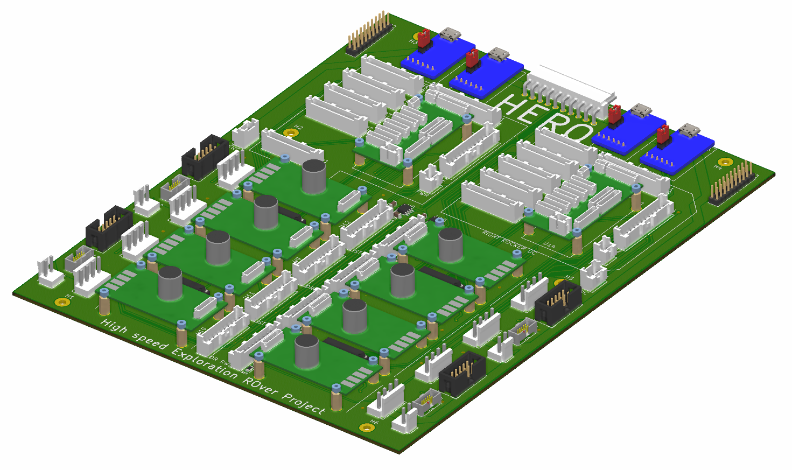

***Fig. 4-4.*** *3D view of the Rocker Interface Unit (RIU).*

The RIU consists of two identical connectivity diagrams—one for each rocker—as shown in Fig. 4.7. It allows all the logical signals and power to be routed towards each respective unit of the ADE. The RIU was designed taking into account the mechanical location of the rocker components. Some of the additional units available in the RIU, which are specified in Fig. 4-5, are defined below.

#### Power connector

It provides the RIU with the power lines required for each of the ADE components and data transfer lines connected to it. Input voltages include 36V, 24V, 12V, and 5V. More details about the power system is provided in Chapter 5.

#### FTDI

A small unit used as an interface for serial communication. FTDI units are in charge of translating the TTL-UART signal from the microcontrollers into the USB protocol required by the P-OBC, and *vice versa*.

#### Line receivers

A unit that consists of an integrated circuit (IC) from Texas Instrument, referenced number SN75175. The prime objective of this unit is to convert the differential output from the built-in encoders of the driving and steering motors into a logic TTL output, directly readable by the motor controllers.



***Fig. 4-5.*** *Top view and individual connectors of the Rocker Interface Unit (RIU).*

#### Current sensing bridge

A unit that consists of a bridge made out of passive components. This was required in order to lower the analog output voltage of the current sensing device built inside the motor driver (from 5V to 3.3V). In addition, it provides low-pass filtering for this signal, smoothing out the effects of the PWM control of the motor. This allows for “average” current readings over a given PWM period, making the readings independent of the actual reading time.

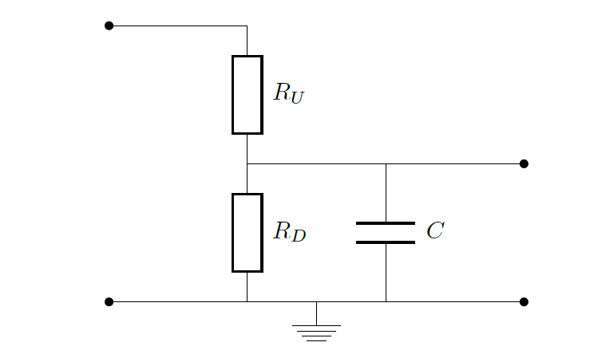

***Fig. 4-6.*** *Schematic of the current sensing bridge built into the RIU.*

#### USB to debug

Two additional FTDI USB ports were included in the design of the RIU (see Fig. 4-5). These ports have been routed directly to additional UART ports on the motor controllers. These ports were included to allow future communication to an additional computer, mainly for debugging purposes, while the rover is being operated in a nominal state (i.e., without the need to disconnect other USB communication paths).

#### Prototyping header

An extra header not connected to anything in particular. It was included in the design of the RIU in order to add a generic connector in the event that an additional component or a prototype of some sort needs to be included in the design. This header allows future students to add new components without the need to use additional wires or modify the design.

*Note: If an extra connection is needed, one can directly solder wires from the pins of the micro controllers to the right pins of the header on the underside of the RIU.*

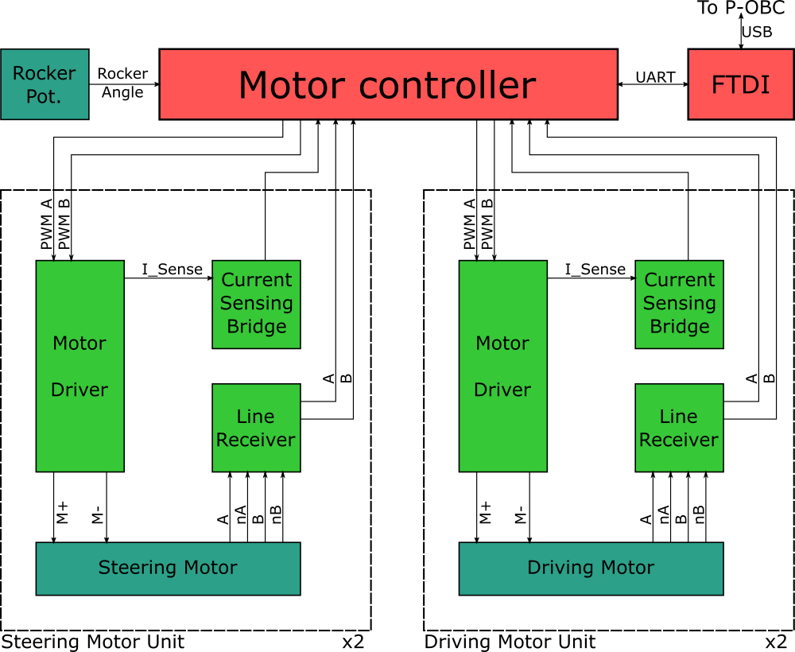

***Fig. 4-7.*** *Connectivity diagram for half of the Rocker Interface Unit (RIU), i.e., all the modules for one single rocker.*

The design of the PCB also required to map each device Input/Output to the right microcontroller pin, a reference of which is available in Table 4-2.

***Table 4-2****. Pinout reference for the microcontroller.*

|  |  |  |  |  |
| --- | --- | --- | --- | --- |
| Function | Description | MCU Pin | Hibot TiTech Pin | Alt. Function Used |
| ENC_ST_FW_1 | ENCoder FSM chan. A | E9 | DIO3_1 | TIM1_CH1 |
| ENC_ST_FW_2 | ENCoder FSM chan. B | E11 | DIO3_3 | TIM1_CH2 |
| ENC_ST_RW_1 | ENCoder RSM chan. A | B4 | DIO1_6 | TIM3_CH1 |
| ENC_ST_RW_2 | ENCoder RSM chan. B | C7 | DIO1_7 | TIM3_CH2 |
| ENC_DR_FW_1 | ENCoder FDM chan. A | A15 | DIO1_1 | TIM2_CH1 |
| ENC_DR_FW_2 | ENCoder FDM chan. B | B3 | DIO1_2 | TIM2_CH2 |
| ENC_DR_RW_1 | ENCoder RDM chan. A | H10 | DIO2_6 | TIM5_CH1 |
| ENC_DR_RW_2 | ENCoder RDM chan. B | H11 | DIO2_7 | TIM5_CH2 |
| MOT_ST_FW_1 | MOTor FSM pwm A | I5 | DIO4_1 | TIM8_CH1 |
| MOT_ST_FW_2 | MOTor FSM pwm. B | I6 | DIO4_3 | TIM8_CH2 |
| MOT_ST_RW_1 | MOTor RSM pwm A | I7 | DIO4_6 | TIM8_CH3 |
| MOT_ST_RW_2 | MOTor RSM pwm B | I2 | DIO4_8 | TIM8_CH4 |
| MOT_DR_FW_1 | MOTor FDM pwm A | D12 | DIO2_1 | TIM4_CH1 |
| MOT_DR_FW_2 | MOTor FDM pwm B | D13 | DIO2_2 | TIM4_CH2 |
| MOT_DR_RW_1 | MOTor RDM pwm A | D14 | DIO2_3 | TIM4_CH3 |
| MOT_DR_RW_2 | MOTor RDM pwm B | D15 | DIO2_4 | TIM4_CH4 |
| CUR_ST_FW | CURrent sensing FSM | F3 | AD2_02 | ADC3_IN9 |
| CUR_ST_RW | CURrent sensing RSM | F4 | AD2_03 | ADC3_IN14 |
| CUR_DR_FW | CURrent sensing FDM | F5 | AD2_04 | ADC3_IN15 |
| CUR_DR_RW | CURrent sensing RDM | F6 | AD2_05 | ADC3_IN4 |
| ANG_RK | AMG;e of RoCKer | F7 | AD2_08 | ADC3_IN5 |
| UART_RX_COM | UART RX COMM to P-OBC | G9 | DIO5_7 | USART6_RX |
| UART_TX_COM | UART TX COMM to P-OBC | C6 | DIO5_6 | USART6_TX |
| UART_RX_DBG | UART RX DeBuG | B10 | DIO1_3 | USART3_RX |
| UART_TX_DBG | UART TX DeBuG | B11 | DIO1_4 | USART3_TX |

## Lights Control Board (LCB).

As briefly mentioned in Chapter 3, the EX1 rover mounts a set of lights intended to be used during low-visibility testing activities. The light set includes two sets of LEDs housed within the Optical Bench of the NAVMAST and a LED bar attached to the front chassis panel. The main functionality of the LCB is to allow the operator to switch the lights on and off from the joystick of the P-OBC as well as to manually and independently regulate the brightness of each light source.

A classical way to control LEDs is to use a MOSFET as a switch and a series of resistors to limit current. This method has the advantage of being simple. However, one major drawback of this simple methodology is that, as time goes by, the LED heats up and its internal resistance subsequently decreases allowing more current to pass through. Over time, the brightness would increase as well as the likelihood of the LED being burned by overcurrent. This issue is often negligible for low-brightness LEDs but it should be considered for higher power applications.

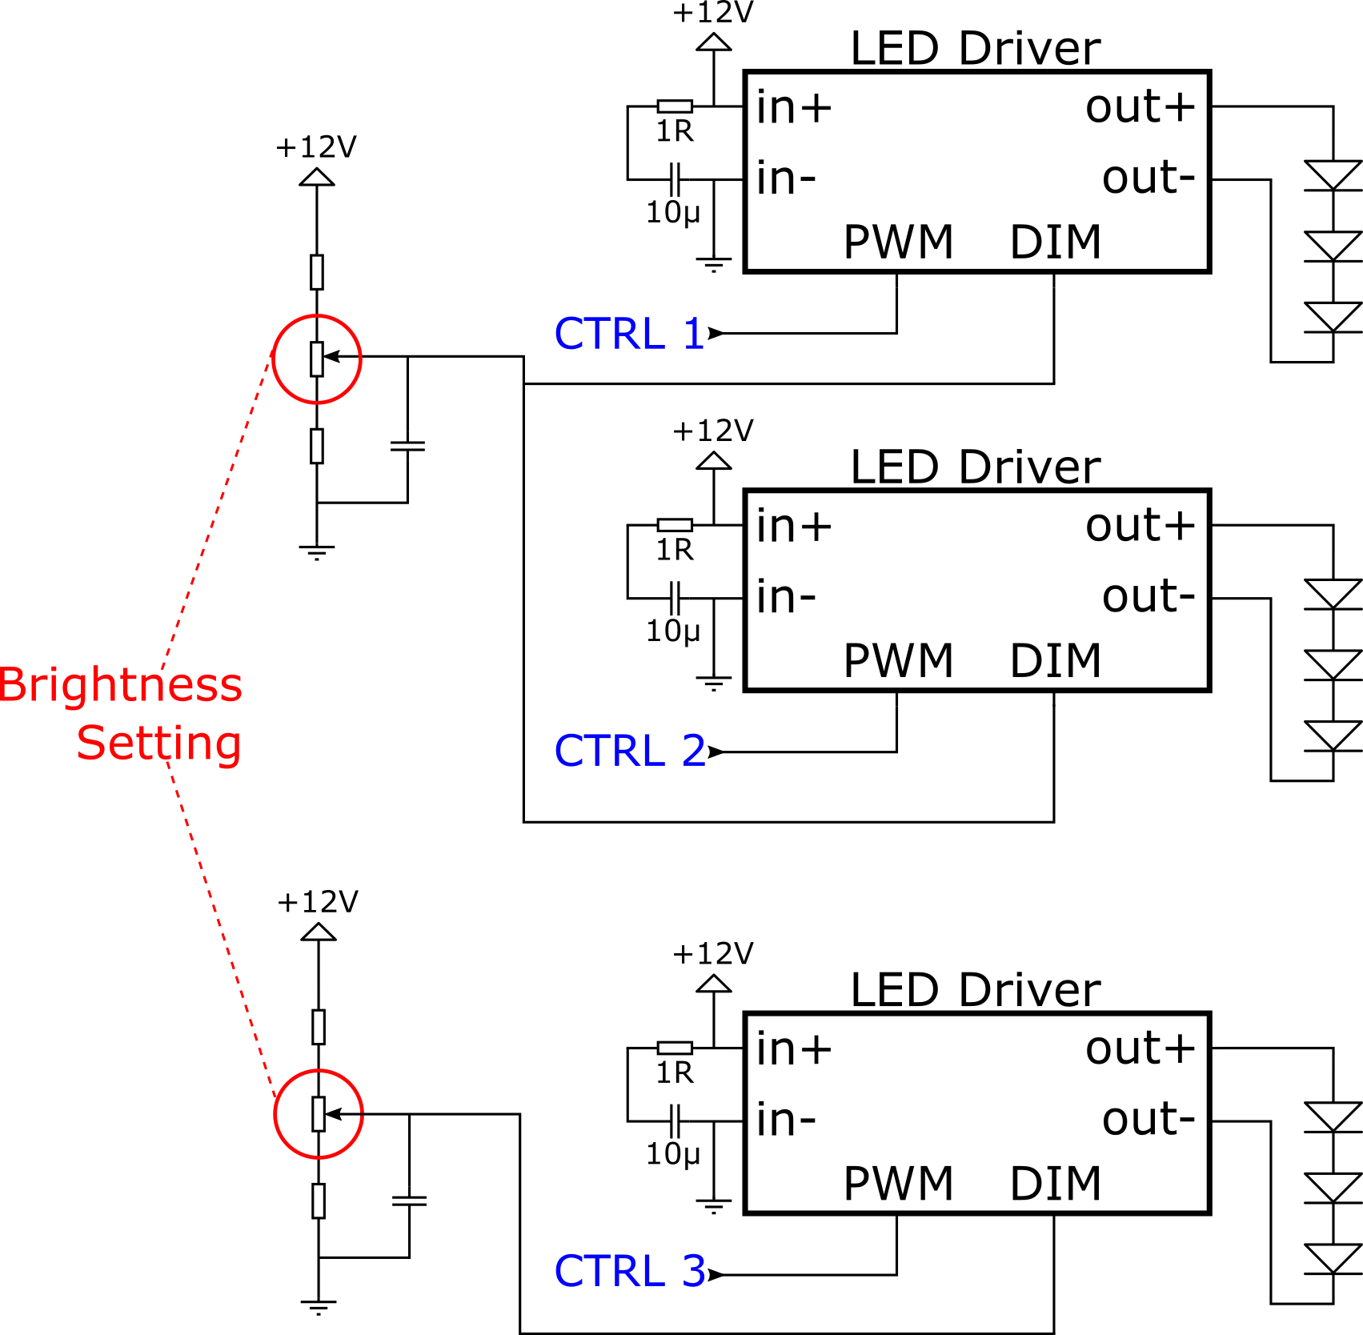

***Fig. 4-8****. Schematic of the Lights Control Board (LCB) circuit.*

In the case of EX1, we opted for the use of constant-current LED drivers instead. These drivers are capable of adapting their output voltage to match the required current. The drivers used are **Recom RCD-24-0.35 LED Driver,** alongside a couple of resistors, capacitors, and trimmer potentiometers to complete the circuit. A schematic of the LCB can be seen in Fig. 4-8. The voltage on the DIM pin adjusts the current passing through the LEDs, acting as an analog dimmer. The PWM pin provides the ON/OFF functionality also known as PWM dimming (more information can be found in the LED driver datasheet, see *Appendix D - Datasheets*). In order to avoid the need to generate PWM signals from the P-OBC, in its place we opted for analog dimming and the PWM pin was used as an ON/OFF switch.

***Table 4-3****. Description of connectors in the Lights Control Board (LCB).*

|  |  |
| --- | --- |
| Port | Properties |
| P-OBC CTRL | CTRL pins to turn ON/OFF each light source. ON = 0V, OFF > 2.9V. |
| POWER_IN | 12V Power input connector. |
| OUTPUT 1 | 0-110 mA, controlled by Trimmer B [LED Bar] |
| OUTPUT 2 | 30-70 mA, controlled by Trimmer A [Right “eye”] |
| OUTPUT 3 | 30-70 mA, controlled by Trimmer A [Left “eye”] |

The final configuration of the LCB is shown below. For the respective GPIO pins used in the P-OBC and their configuration, refer to Section 8.4.

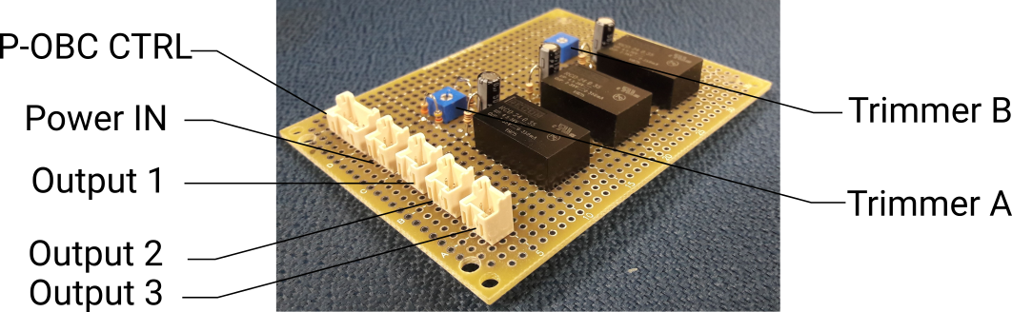

***Fig. 4-9.*** *Lights Control Board (LCB).*

## Inertial Measurement Unit (IMU).

Directly mounted to the SVM and connected via USB to the P-OBC is a **USB Output 9-axis IMU sensor module** (MPU9250) from RT Corporation. IMU data, including values from the built-in temperature sensor, are directly sent and stored in the P-OBC. The IMU sensor module was mounted as close as possible to the top surface of the SVM and as far as possible from strong electromagnetic field sources (i.e., inductors such as motors and power supplies) so as to minimize noise and data interference.

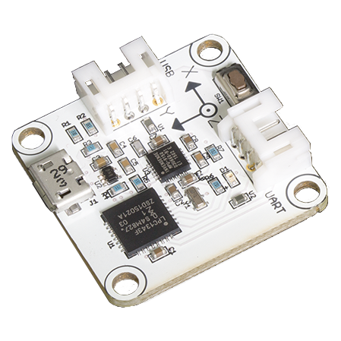

***Fig. 4-10.*** *IMU sensor module.*

# Power system design.

## General architecture.

EX1 power system was designed with the objective to minimize the overall size and weight required to provide with sufficient power to all rover systems and subsystems while guaranteeing that peaks of power demand could be met and that individual components were properly protected from potential power surges. To accomplish this, power is provided exclusively through two **18V 6000mAh LiFe batteries** weighing 650 gr each. LiFe batteries were chosen over LiPo batteries due to their overcharge and overdischarge protection. These batteries are mounted onto the top chassis panel. Five different power lines are required to provide all rover systems with their required voltages: 5 V, 12 V, 14.5 V, 24 V., and 36 V.

In the absence of power generation devices, such as PV solar panels, EX1 power system comprises primarily two battery units and the **Power Conditioning and Distribution Electronics (PCDE) module**; i.e., a set of two PCBs that work together to convert input power into required output power and redistribute this to the different components in the system. The two PCBs that comprised the PCDE are called the **Power Supply Unit (PSU)** and the **Power Distribution Unit (PDU)**, both of which are described in the following sections.

In order to protect the different subsystems against power surges a series of 10 A fuses were allocated throughout the high-power lines. To make sure power output is always controlled by the operator, an Emergency Off (EMO) switch and a set of toggle switches were incorporated into the design (for more details, refer to Section 5.2 and Fig. 8-1.). For details on the procedure to power up the rover, refer to Section 8.1.

The general power system architecture is depicted in Fig. 5-1.

*Note: A simpler design for the PSU was proposed due to some manufacturing- and logistics-related issues experienced during the development of the initial PSU design. The current version in use does not incorporate specifically designed (external) power protection systems. The current design of the PSU should be regarded as a functional prototype designed and built by people with limited experience in power systems. Future students are encouraged to reassess the design of the power system to increase its robustness and reliability.*

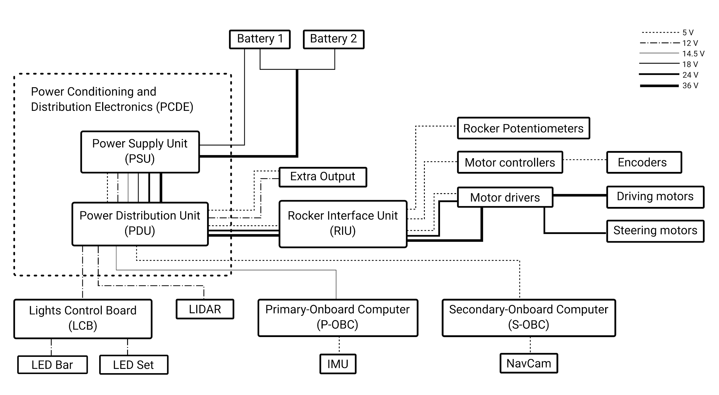

***Fig. 5-1****. EX1 power system architecture.*

## Power Supply Unit (PSU)

The Power Supply Unit (PSU) is a simple prototyping board in which main power inputs and outputs are allocated. In order to simplify the design, off-the-shelf DC-DC converters were used. In particular, the 24 and 14.5 V conversion was accomplished by means of two programmable **Mini-box DCDC-USB Intelligent buck-boost converters**. General characteristics of these two modules are provided in Table 5-1. In the case of the 5 and 12 V conversion, a **Cosel MGFS302412 and a Cosel MGFS302405 DC-DC power conversion modules** were used. These two modules were previously mounted on ElDorado 2 rover. Refer to Table 5-2 and Table 5-3 for general specifications. Further details can be found in *Appendix D - Datasheets*. A schematic of the PSU is presented in Fig. 5-2.

***Table 5-1****. Mini-box DCDC-USB converter specifications.*

|  |  |
| --- | --- |
| Characteristics | Value |
| Power | 100 W |
| Input range | 6-34 V |
| Output range | 5-24 V |
| Max. current | 10 A |

***Table 5-2****. Cosel MGFS302412 DC-DC converter specifications.*

|  |  |
| --- | --- |
| Characteristics | Value |
| Power | 30 W |
| Input range | 9-36 V |
| Default output | 12 V |
| Max. current | 2.5 A |

***Table 5-3****. Cosel MGFS302405 DC-DC converter specifications.*

|  |  |
| --- | --- |
| Characteristics | Value |
| Power | 30 W |
| Input range | 9-36 V |
| Default output | 5 V |
| Max. current | 6 A |

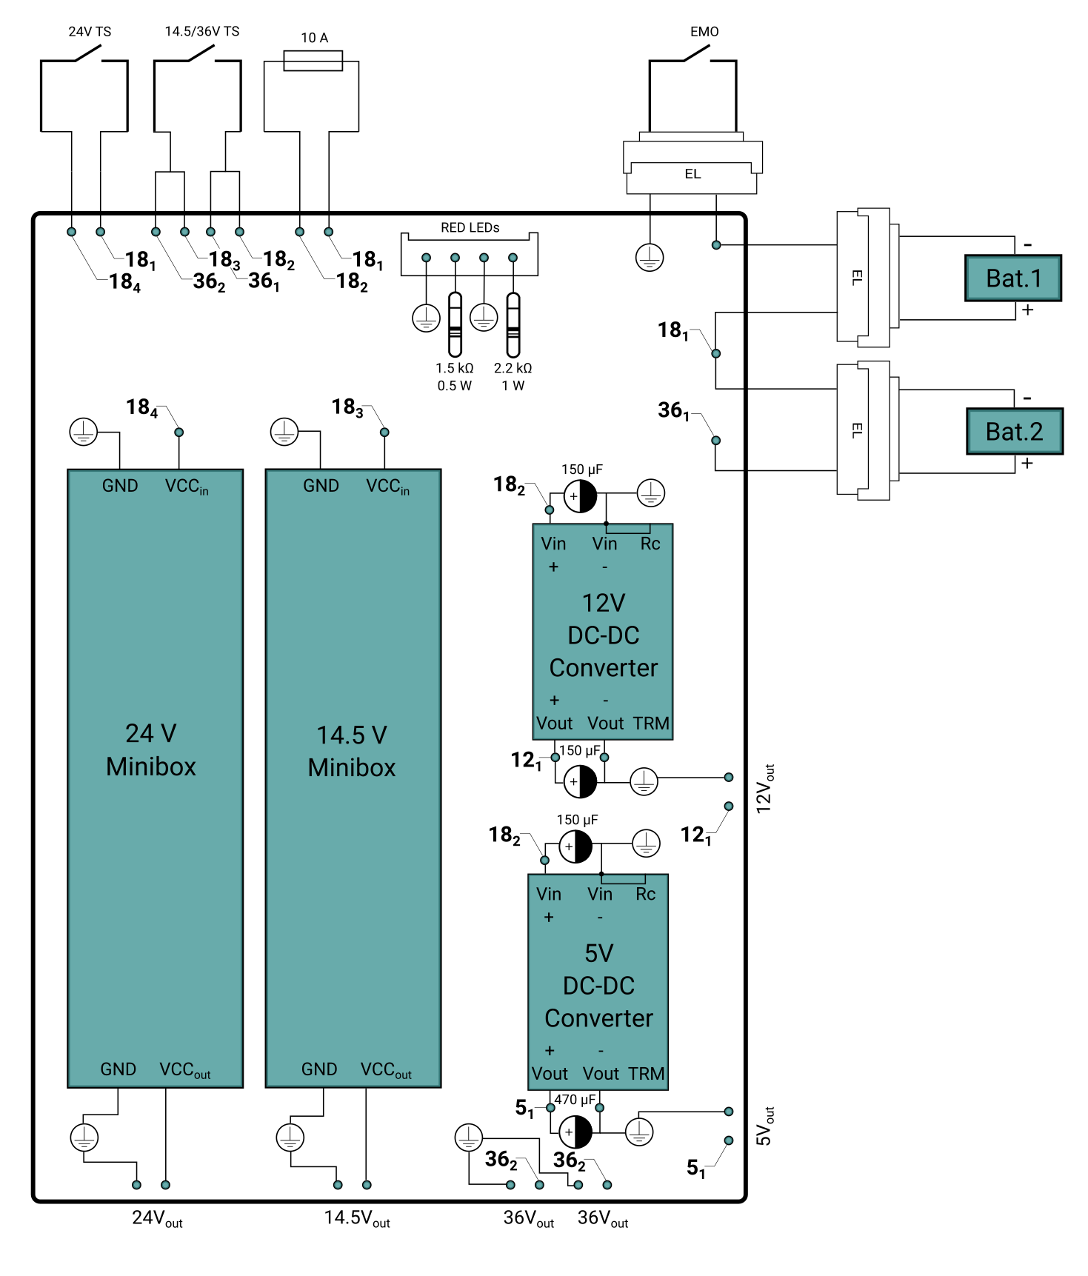

***Fig. 5-2.*** *Power Supply Unit (PSU).*

## Power Distribution Unit (PDU)

The Power Distribution Unit (PDU) consists of a rather simple PCB, the objective of which is to reroute the power outputs from the PSU to the different components in the system. The final PDU design can be seen in Fig. 5-3.

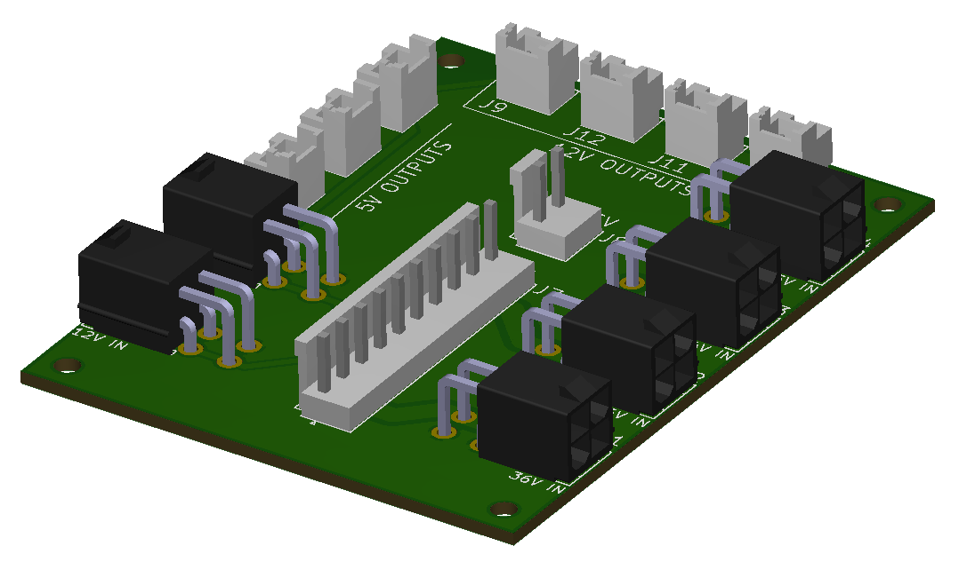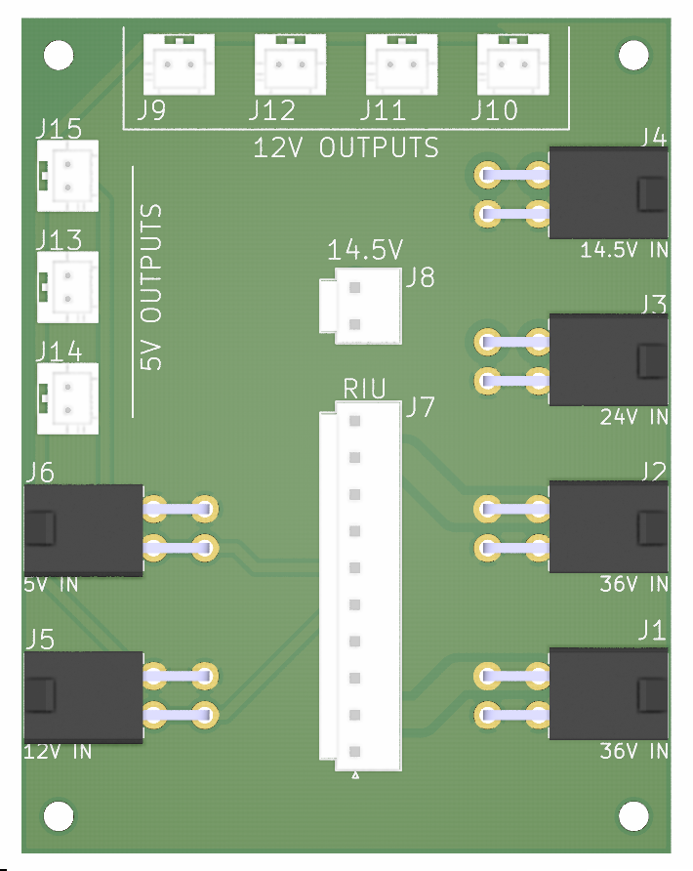

***Fig. 5-3.*** *Power Distribution Unit (PDU) 3D and top views.*

# Software and data handling.

## Overview.

The following chapter introduces EX1 software design. This can be divided into two main parts: one regarding the central operating system (OS) and one regarding low-level control software. The central OS runs on the P-OBC and supports the following general functionality:

* Wireless communication with Ground Control Station (GCS) via a WiFi Network.
* Wireless communication with Teleoperation Joystick via Bluetooth 4.1.
* High-level control tasks, in particular those related to locomotion, i.e., driving forward/backwards and steering.
* Serial communication of commands with low-level control software.
* Telemetry data retrieval and storage.
* On/Off switch of low-visibility lights.

On the other hand, the low-level control software is in charge, as the name suggests, of handling low-level control tasks; thus, it runs primarily on the motor controllers of the ADE. Low-level software general functionality includes:

* Communication with central OS for the transmission of commands and telemetry data requests.
* Execution of low-level control tasks.
* Reading ADE sensors data.

## Operating system.

The central OS is based on the **Robot Operating System (ROS)** **platform**, in particular, the **Melodic Morenia distribution** over **Ubuntu 18.04**. The code is, for the most part, implemented in **C++**. All the code associated with the central OS can be found in the repository *h*[*ero_ex1_sw*](https://bitbucket.org/hero_team/hero_ex1_sw) at HERO team’s bitbucket workspace (<https://bitbucket.org/hero_team/>). The complete node graph can be seen in Fig. 6-1. The vast majority of the nodes and topics created are used as part of the internal communication protocol (refer to Section 7.2.). For details on the different topics, custom message types, and nodes used, one should refer directly to the actual files in *h*[*ero_ex1_sw*](https://bitbucket.org/hero_team/hero_ex1_sw) repository.

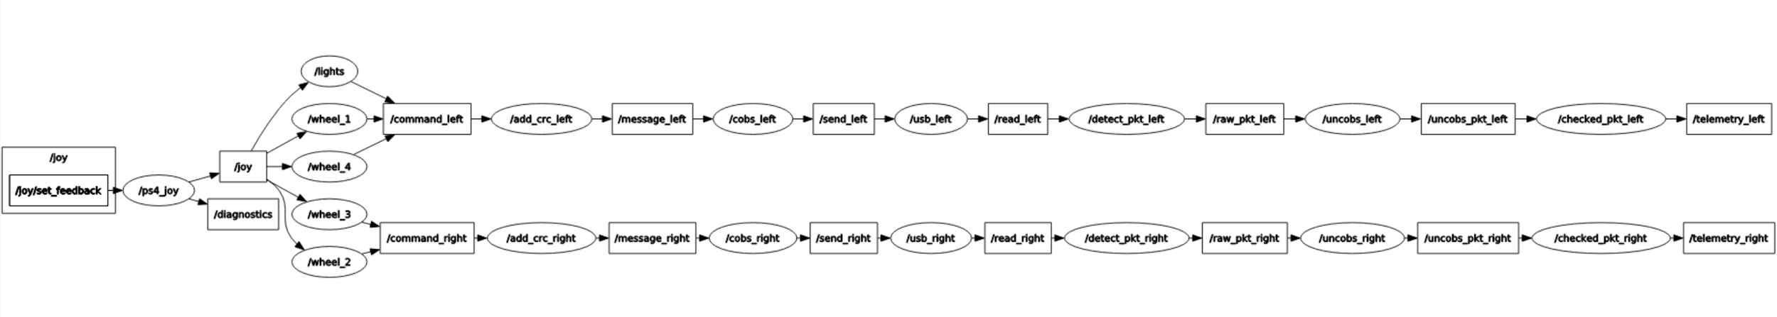

***Fig. 6-1.*** *ROS node graph of the central OS.*

## Low-level software.

As already mentioned, the low-level software is implemented in the motor controllers and it is, therefore, in charge of listening and executing orders received from the central OS running on the P-OBC, informing the central OS of the current state of all the ADE components at a frequency high enough to allow the central OS to be able to make automatic decisions on a timely manner. The language used for the low-level software implementation was **C**. All the related code can be found in the [*3_ex1_hibot_sandbox*](https://bitbucket.org/hero_team/3_ex1_hibot_sandbox) repository.

The Integrated Development Environment (IDE) used for developing the low-level software was **Eclipse for C/C++[3] with the associated GNU for ARM Embedded programming toolchain**. For more detailed information, the HiBot company made a tutorial on how to link Eclipse with the HiBot Titech M4 micro-controller[4]. All the low-level software code has been appropriately documented using the **Doxygen[5] syntax** and the available Doxygen plugin for Eclipse. It results in a so-called embedded documentation that everyone can generate on demand in both PDF and HTML format.

A more detailed functionality of the low-level software, which will be explained in the following sections, include:

* Communication of commands with central OS.
* Execution of commands. In particular, automatic speed (driving motors) or position (steering motors) control for each motor. This includes:
  + Double PWM application to each motor driver.
  + Reading output through encoder data.
  + Automatic adjustment based on closed feedback loop.
* Constant supervision and report to the central OS of the ADE state; this includes: data of the position and velocity of steering motors, velocity of driving motors, current drawn by each motor, and individual rocker angles.

*Note: the following subsections provide an in-depth description of how the low-level control tasks were implemented and the functionality and theoretical principles behind them. They are not considered absolutely necessary unless low-level improvements are intended. General users of the EX1 platform are encouraged to skip these sections*

### Motor control.

A motor driver consists primarily of an H-bridge—a circuit of 4 switches—allowing a motor to turn both clockwise (CW) and counterclockwise (CCW). Its principle of operation is shown on Fig. 6-2. As can be seen, the direction of rotation of the motor can be controlled based on the On/Off configuration of the H-bridge

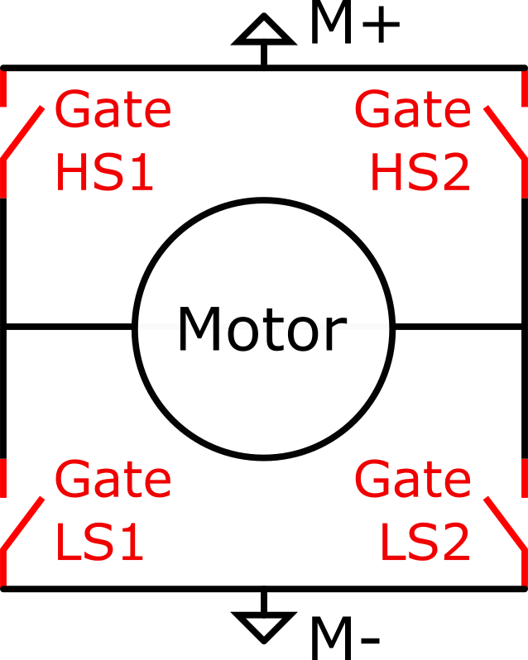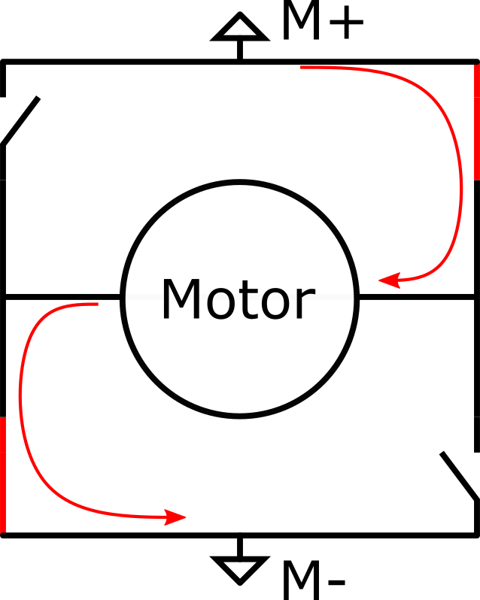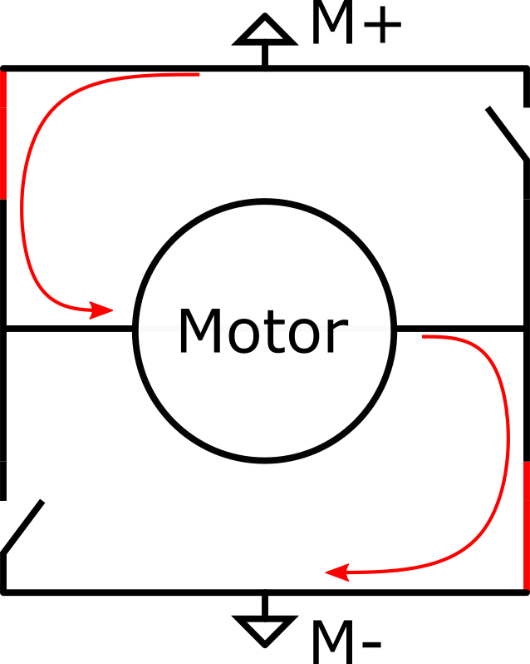

1. *H-bridge gates naming convention. (b) CW configuration (c) CCW configuration.*

***Fig. 6-2.*** *Working principle of an H-bridge.*

In order to control a motor through its motor driver in both CW and CCW directions, two PWM signals are required (PWM AL and PWM BL) as per the truth table displayed in Table 6-1.

***Table 6-1****. Truth table of the H-bridge.*

|  |  |  |  |  |  |
| --- | --- | --- | --- | --- | --- |
| PWM AL | Gate LS1 | Gate HS1 | PWM BL | Gate LS2 | Gate HS2 |
| 0 | Open | Closed | 0 | Open | Closed |
| 1 | Closed | Open | 1 | Closed | Open |

In order to control a motor as wanted, one needs to follow the chronogram shown in Fig. 6-3. It should be noted that in order to change the speed of rotation, it is possible to change the duty cycle of the active PWM (i.e., change the time at low-state for the non-constant PWM signal).

*Note: It is also important to note that the motor driver used does not make use of a built-in charge pump. This means that the duty cycle of the input PWM signal has to be necessarily between 10% and 90%. Tests were conducted outside this range and the consequences have been spurious and jittering effects experienced by the motor. This should be regarded over the 5% to 95% working range described in the motor driver datasheet (see Appendix D - Datasheets).*

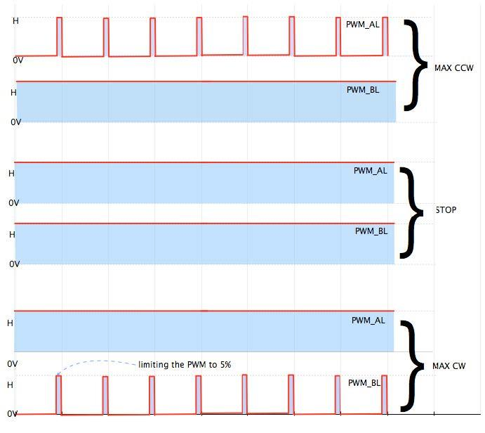

***Fig. 6-3.*** *Different command signals applied to the H-bridge and their effect.*

The PWM signals are directly generated by the built-in timers of the micro-controllers. The level of command is directly linked to the duty cycle of the active PWM. The PWM frequency has been chosen to be 32 kHz for the following reasons:

* A frequency above 20 kHz ensures a reduction of motor operating noise.
* The selected frequency needs to be low enough to comply with the driver capabilities, in this case 200 kHz based on the motor driver data sheet (see *Appendix D - Datasheets*).
* A slower PWM frequency implies that more clock ticks exist during one PWM period and, consequently, the accuracy over the duty cycle (the command level) improves.
* Due to the motor being a second-order low-pass electro-mechanical filter, the higher the frequency, the smoother the output.

The *motor_driver* package includes initialization functions and an apply-command function. This apply-command function changes the active PWM and its duty cycle according to the sign of its argument and its magnitude. Note that this apply-command function has nothing to do with automatic control; it only applies a raw command. Automatic control will be the subject of another section.

### Encoder reading.

Each motor comes with a built-in quadrature encoder; i.e., a relative angular positioning sensor. A quadrature encoder is capable of providing information on both displacement and direction of motion. This type of encoders are characterized by the number of ticks per revolution, which in turns dictates its level of accuracy. By counting the number of ticks on the output of the encoder, one can linearly compute the angle of displacement.

#### Position reading

The microcontrollers used on EX1 come with a built-in encoder interfacing hardware. This allows us to have an accurate counting mechanism without completely depleting the computational resources of the microcontroller. This interfacing hardware feeds a N-bits (32 its for driving motors, 16 bits for steering motos) counter that keeps track of the number of ticks given by the encoder.

In order to be able to record both CW and CCW rotations, the counter is initialized at *Co=2N-1*. The total angular displacement on the output shaft with respect to the initialization time of the counter is given by:

$ΔA = ΔC · Res · Red$,

where $ΔA$ is the total output travel in degrees, $ΔC$ is the difference from reference point in the interface counter in number of ticks, $Res$ is the resolution of the encoder in degrees/tick, and $Red$ is the reduction factor between the motor and the output shaft (smaller than 1 in this convention).

One may notice that there is a problem for $ΔA >$*2 N-1* . This is due to the counter not being able to count anymore; this problem is known as overflow or underflow and will be covered later on.

Assuming that over- or underflow has not happened yet, the angle of the output shaft with respect to the startup angle can be known at any moment in time, by simply reading the counter and using the formula previously mentioned.

#### Speed calculation

Unlike position reading, speed calculation requires dealing with time. Speed calculation requires a first order derivative at an approximately constant rate. This has two major effects. On the one side, the position is known with a quantization error, meaning that deriving over extremely short periods of time will result in very noise-prone and inaccurate results. On the other side, if the derivative time step is too long, the automatically controlled system becomes slow and unstable in its response.

In order to protect against noisy outputs due to short derivation periods, the speed computation function stores its last call timestamp and acts consequently (i.e, by giving the last speed value known if the last function call is below a time threshold, or otherwise too recent). To protect against excessively long derivation periods, the speed computation function is periodically called, regardless of whether it is needed or not, in order to keep the system up to date on the motor speed.

Taking the derivative of the position between 500𝜇s and 10ms has so far proven to be qualitatively and experimentally acceptable for our application. The speed is then given by

$dA/dt = ΔA / Δt$

#### Handling over- and underflow

A preventive software action was implemented in order to deal with this problem. At a certain amount of ticks before over- or underflow occurs, an interrupt signal is emitted. The ticks counter is immediately reset to its middle position *2N-1* before incrementing (when underflown) or decrementing (when overflown) the counter.

The total angle travelled is then given by the following equation.

$ΔA = (ΔC + nM) · Res · Red$,

where $n$ is the algebraic number of over- or underflow (a negative number indicates underflow while a positive number indicates overflow) and $M$ is the number of ticks between the middle position and the number of ticks at the moment when the interrupt was sent in absolute value. As you may expect, the interrupt signal needs to be emitted before an over- or underflow occurs and not exactly at this moment ( $M ≠$*2 N-1).*

### Automatic motor control.

For both steering (position control) and driving (speed control), the **control scheme** is a **single input** (speed or position measured by the functions mentioned earlier) **single output** (active PWM selection and magnitude) **PI** (Proportional Integral) **loop**. Some extra functionalities were included, such as integral saturation.

Proportional action is taken to have "reactivity" in the system, and to reduce the time needed for the system to reach the set-point. Integral action is taken to cancel the error over time, making it tend towards zero as time increases. These two values—proportional and integral gains—have been tuned experimentally.

*Note: Indeed, automatic control is a science field of its own, and a lot more could have been done to characterise and model the responses and reactions of the system depending on the control algorithm, the strategy employed, the way to compute velocity, etc. Future students may consider looking deeper into this subject.*

A derivative term was not introduced, as derivative gains add a lot of complexity to the tuning process and the computation process.

*Note: One should keep in mind that a third term to tune means another dimension in the space of available tunings and it takes more time to explore it. A derivative term also implies, for speed control, that the digital signal (the encoder output) had to be derived twice, resulting in even more noisy and inaccurate outcomes if special derivation techniques, which are often mathematically complex, are not implemented.*

Additionally, a set band has been put in place for position control, as readings from an encoder (which is discrete) and a given setpoint cannot exactly match. A control frequency sequence was also implemented. As our control is not a continuous control but a discrete one, instability is introduced by the control algorithm itself. The lower the frequency of operation, the more unstable the system becomes, but on the other hand, the higher the frequency of operation, the more computational resources are needed from the microcontroller.

Measurements were taken through UART (see Section 7.2. for details on the communication protocol implemented) for different frequencies of operation. One can see in Fig. 6-4 and Fig. 6-5 the effect of increasing the frequency of operation. Oscillations are easily observed on Fig. 6-4 and are highlighted on Fig. 6-5. Experimentally, **we choose to have a frequency of operation of 100Hz** as a good compromise. The control is good enough, and there is still plenty of CPU resources available for other tasks

.

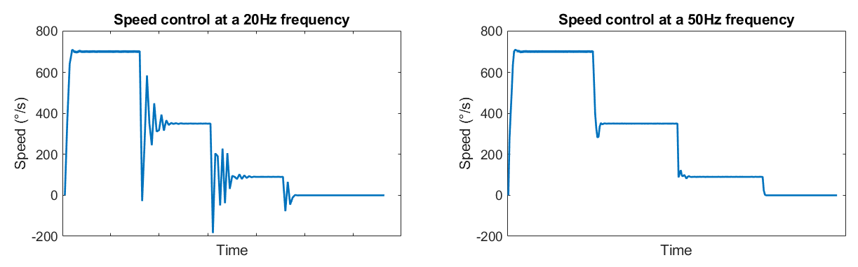

***Fig. 6-4****. Speed control with consecutive step commands for two different frequencies of operation.*

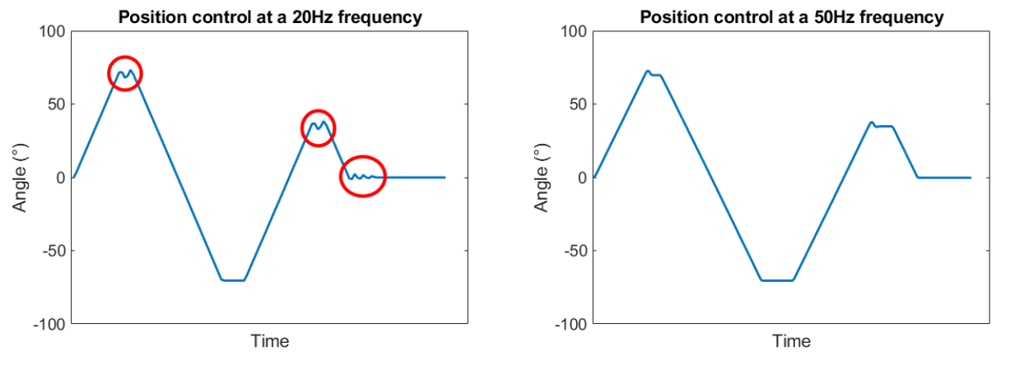

***Fig. 6-5****. Position control with consecutive step commands for two different frequencies of operation.*

### Analog reading.

Analog reading is used to read the current going through the driving motors. Current is an analog value given by the current reading device built in the motor driver. Analog reading is also used to measure the angle of each rocker, using a potentiometer between the main chassis and the rocker shaft. In this case, an analog value lies between 0 and 3.3V with a 12bits Analog to Digital Converter (ADC) (i.e. it outputs values between 0 and 4096).

After experimental testing it was noticed that a constant input had a variation of approximately 6 bits in magnitude, which means we can assume a deviation of $\frac{6}{4096}≈0.14\%$ on the result (this will be taken into account in the post-processing phase). The post-processing phase includes filtering in order to smooth out the ADC variation and the PWM control inherent current variations (motor turning on and off a fast rate). Remember that the latter has been already partially cancelled by the hardware filter described in the previous section.

An overview of how the higher layer of the low-level control software works is shown in Fig. 6-6. To completely understand this diagram one should be familiar with the internal communication protocol described in Section 7.2.

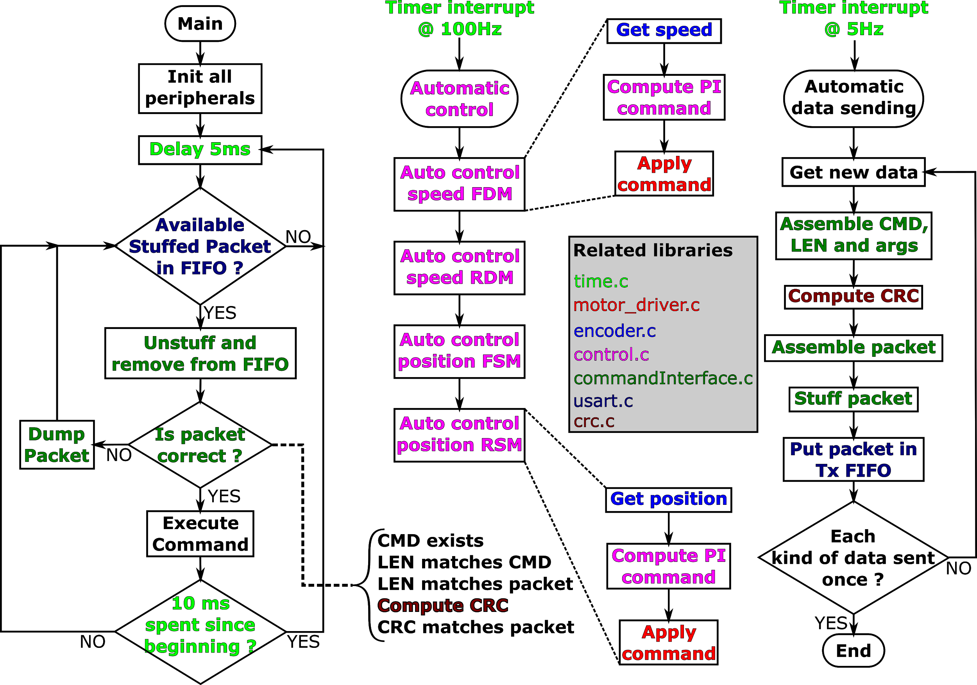

***Fig. 6-6.*** *Overview of the high-level functions implemented in the low-level software*.

## On-board data handling system.

All the sensor data is received by and stored in the following directory of the P-OBC.

*/home/rovertx2/HERO_EX1/src/ex1_startup/record/*

Data is stored in three different rosbags[6], namely:

* ***telemetry_right_.bag***: with information pertaining to all proprioceptive sensors allocated in the right rocker.
* ***telemetry_left_.bag***: with information pertaining to all proprioceptive sensors allocated in the left rocker.
* ***imu_data_.bag***: with information of accelerations, orientation, and internal temperature provided by the IMU.

*Note: Telemetry data is not stored by default. One should pass a specific argument when running the startup launch command as specified in Section 8.2.2 in order for the rosbags to be initialized.*

# Communication system.

## Overview.

EX1 communication system architecture was designed, for the most part, with the objective to maximize reliability. Common errors associated with data transmission include the reception of erroneous or uncompleted messages, the presence of noise in the data, interferences, missing incoming message characters, and synchronization errors, among others. Given the importance associated with the transmission and reception of data, a First In First Out, or FIFO, paquet structure was implemented as part of EX1 internal communication protocol (details in Section 7.4). Specific routines for the identification, evaluation, manipulation, and elimination of such errors were implemented. Overall, three main lines of communication can be identified as presented in Fig. 7-1.

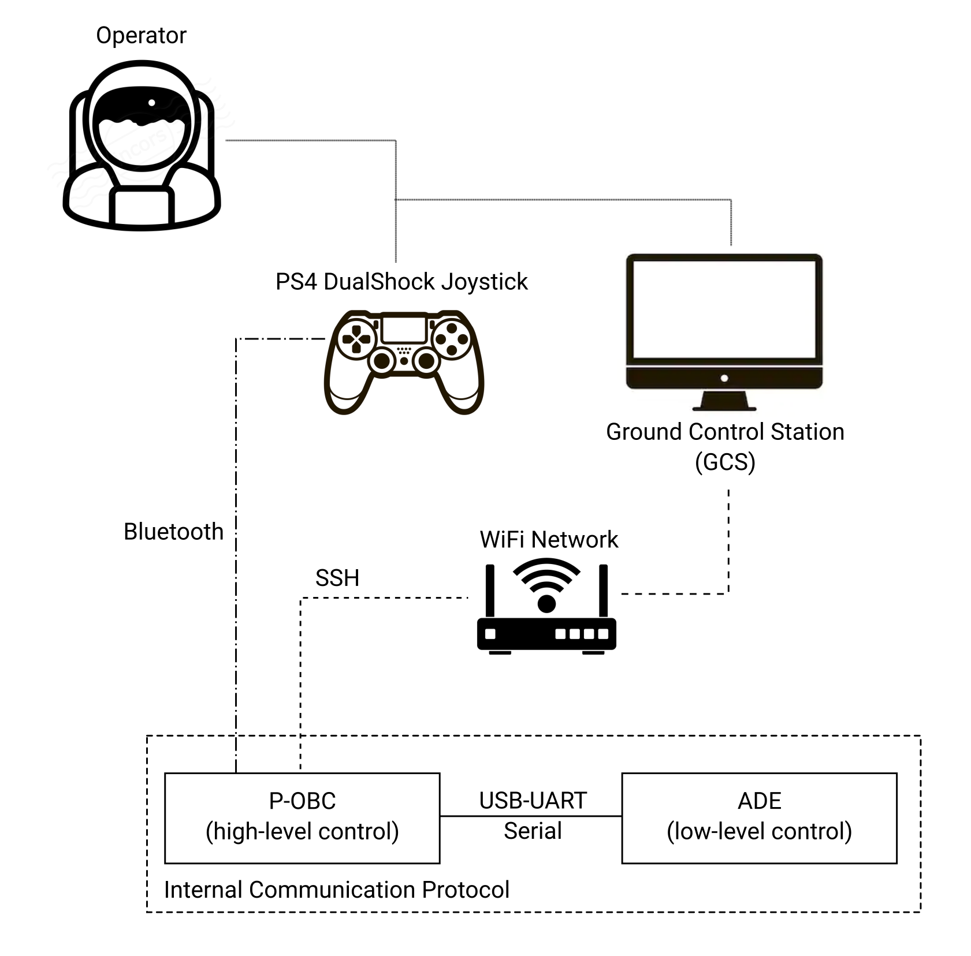

***Fig. 7-1.*** *Simplified communication system architecture.*

One should note that, despite the pursuit of reliability in the communication system, certain components of the current architecture were chosen due to their immediate availability and ease of use. One such example is the teleoperation joystick. While bluetooth provides a direct and easy connection to the P-OCB, its short range, low data security, and low speed makes it a poor candidate as a long-term solution. Future users of the platform are encouraged to further investigate other alternatives such as the addition of a radio control module.

## Internal communication protocol.

EX1 internal communication protocol between the P-OBC (high-level control tasks) and the micro-controllers of the ADE (low-level control tasks) was implemented through **USB-UART serial communication** by which **custom packets of information** were exchanged. These packets contained, when sent by the P-OBC, information about the commands triggered through the joystick by the operator and, when sent by the micro-controllers, telemetry data fed back to the GCS by the proprioceptive sensors of the ADE (i.e., motor encoders, current sensors, rocker potentiometers) and the IMU readings (accelerations, orientation, and internal temperature).

As specified in Section 4.3., FTDI modules are being used to handle the conversion from UART-TTL to USB and vice versa. For this reason, in order for the ADE to communicate with the P-OBC, all it is required is to send our custom framed packets under UART protocol (i.e., one byte at a time). In the opposite direction—from the P-OBC to the micro-controllers of the ADE— command packets were defined and framed in the same way but the final transmission via USB was handled by a specific ROS serial library.

### UART driver.

In order for messages to be communicated and decoded properly by the P-OBC, the UART controller of the moto controllers were set with the following parameters.

***Table 7-1****. UART communication settings.*

|  |  |  |  |
| --- | --- | --- | --- |
| Parameter | Value | Units | Definition |
| Baud rate | 115200 | bit/s | Frequency of transmission |
| Stop bit(s) | 1 | bit | Number of stop bit(s). Can be 1, 1.5, or 2. |
| Data size | 8 | bit | Number of useful (non-framed) bits in a frame. Can be 8 or 9. |
| Parity | N.A. | - | Presence or not of a parity bit. Can be 0 or 1 bit, even or odd. |

These settings imply that the efficiency of transmission is 80%[7]. In order words, for each byte we want to send, we need to send 10 bits. The maximum sending frequency is then 92,169 bits/s[8]. Each sending device must be ensured not to exceed this maximum rate.

Once the settings are defined, reading and sending data through UART is rather simple. One major drawback of the UART protocol is, however, that only two registers exist on which devices can read and write raw bytes of information. When a new byte is received, this is automatically written in the register. The reader can now access this register at any time to retrieve the byte sent. But the register can only store one byte at a time. This means that if before the initial byte sent is retrieved and read, a second byte is sent, this second byte will be automatically discarded from the register precluding the possibility to read it. In addition, a full message is often formed by more than one byte. A process to retrieve, read, and temporarily store these bytes of information until a full message is received had to be implemented: this is what is called a **buffer**.

*Note: One could set up a UART communication without the need of a buffer by forcing the writer to wait before sending a byte until the previously sent byte has been properly read. This, however, introduces a lot of inefficiencies to the communication protocol.*

### Ring FIFO Buffer.

A **ring First In First Out (FIFO) or queue buffer** was implemented in the internal communication protocol. This makes storing bytes of information (more than one at a time) possible until they are fetched and processed by the reader. The FIFO or queue structure ensures that, regardless of the number of bytes sent, the information is always stored and processed in the correct order; i.e., from when the last processing ended.

FIFO structures make use of a ring. A ring consists of a circular structure that avoids the need for shifting elements in the queue from tail to head every time a new byte is received and stored. Instead, the queue advances around the ring (looping the circular structure). The head and the tail of the queue simply moves backwards (the tail grows) around the ring as new information arrives. An example of how a FIFO ring works is presented in Fig. 7-2.

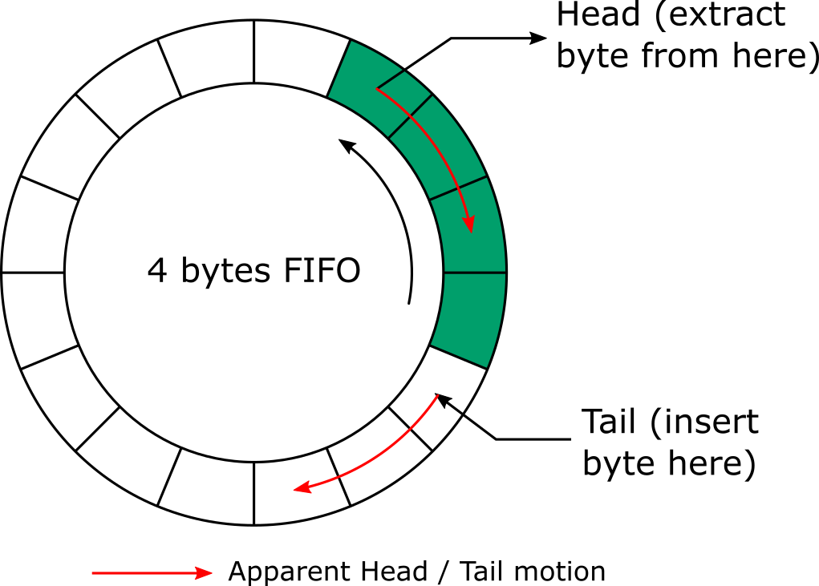

***Fig. 7-2.*** *How a FIFO ring works.*

When utilizing FIFO ring structures, two FIFOs are actually being used: a transmit FIFO and a receive FIFO. Their functionality is slightly different. If interested, more information can be read online about FIFO rings and their functionality.

### Packet architecture.

A packet can be defined as a complete message that contains direct information—useful information for the reader, e.g., a command and its value—and safety information—information used to verify the integrity of the message being read. A packet is composed of different sets of information or arguments (see *Arg. Name* column in Table 7-2). The size of any packet will be between 8 and 24 bytes. The structure of the packets used for EX1 internal communication protocol is described in Table 7-2.

***Table 7-2****. EX1 internal communication protocol packet description.*

|  |  |  |
| --- | --- | --- |
| Arg. Name | Size [bytes] | Description |
| ID | 2 | A unique message identifier. |
| CMD | 1 | Specific command code to be executed. |
| LEN | 1 | Size (in bytes) of the DATA section. Max value is 16. |
| DATA* | LEN | Arguments associated with the command CMD. |
| CRC | 4 | CRC code to ensure the message is free or errors. |

*DATA is an optional argument used when LEN ≠ 0.

In addition to a custom packet definition, a **safety verification procedure** was implemented in order to make sure that packets being read and ultimately processed are free of errors. A packet would be qualify as uncorrupt (i.e., good to be processed by the reader) if:

* CMD corresponds to a valid command within the dictionary (see Section 7.2.4.).
* LEN should match the required data length of CMD.
* The total size of the packet should always be equal to 8 bytes + LEN.
* The CRC should correspond to the packet being read (more details on the CRC process implemented are presented in Section 7.2.5.)

If any of the previously described requirements is not met, the packet will be automatically discarded. Uncorrupt packets will be processed by the reader (the P-OBC or the micro controllers depending on what information is being shared).

### Dictionary of commands.

Each packet transmitted corresponds to either information requested by the P-OBC (e.g., telemetry data) or commands sent by the P-OBC (e.g., move forward at 0.2 m/s). Table 7-3 describes the different commands and Table 7-4 describes the different pieces of information available within the internal communication protocol.

***Table 7-3****. Commands sent by the P-OBC.*

|  |  |  |  |  |
| --- | --- | --- | --- | --- |
| Command name | Description | CMD [hex.] | LEN | DATA (unit) [Type] |
| LIGHTS_ON | Turn on a built-in debug LED | 0x01 | 0 | N.a. |
| LIGHTS_OFF | Turn off a built-in debug LED | 0x02 | 0 | N.a |
| SETSPEED_FRONT | Set the speed of the FDM | 0x03 | 4 | Speed (deg/s) [float] |
| SETSPEED_REAR | Set the speed of the RDM | 0x04 | 4 | Speed (deg/s) [float] |
| SETSTEER_FRONT | Set the angle of FSM | 0x05 | 4 | Angle (deg) [float] |
| SETSTEER_REAR | Set the angle of the RSM | 0x06 | 4 | Angle (deg) [float] |

FMD= Front driving motors, RDM= Rear driving motors, FSM = Front steering motors, RSM = Rear steering motors.

***Table 7-4****. Data sent to the P-OBC.*

|  |  |  |  |  |
| --- | --- | --- | --- | --- |
| Data name | Description | CMD [hex.] | LEN | DATA (unit) [Type] |
| VAL_SPEED_FRONT | FDM speed | 0x07 | 4 | Speed (deg/s) [float] |
| VAL_SPEED_REAR | RDM speed | 0x08 | 4 | Speed (deg/s) [float] |
| VAL_ANG_FRONT | FSM angle | 0x09 | 4 | Angle (deg) [float] |
| VAL_ANG_REAR | RSM angle | 0x0A | 4 | Angle (deg) [float] |
| VAL_CURR_FRONT | Current through the FDM | 0x0B | 2 | ADC_out (/)* [uint16] |
| VAL_CURR_REAR | Current through the RDM | 0x0C | 2 | ADC_out (/) [uint16] |
| VAL_ANG_RCK | Rocker angle | 0X0D | 4 | Angle (deg) [float] |

FMD= Front driving motors, RDM= Rear driving motors, FSM = Front steering motors, RSM = Rear steering motors.

*The ADC is a 12-bit ADC. This means that the resolution of the ADC is 4096 (2^12) discrete levels. 5V = 4096.

*Note: Look at the config file cmdlist.yaml as a reference.*

### Cyclic Redundancy Check (CRC).

*“A cyclic redundancy check (CRC) is an error-detecting code commonly used in digital networks and storage devices to detect accidental changes to raw data. Blocks of data entering these systems get a short check value or CRC value attached, based on the remainder of a polynomial division of their contents.”*

In our case, the CRC consists of a 32 bits value calculated based on the remaining arguments of the transmitted packet. The CRC of each packet will be first calculated by the writer (the transmitter) and attached to the remainder of the packet. The reader (receiver) will then receive the packet, retrieve all the arguments except for the CRC, recalculate the CRC, and compare it to the CRC attached to the packet by the writer. The value provided by the use of CRC is that if during transmission the information contained in the packet or the CRC itself is altered, upon recalculating the CRC on the reader side this type of data corruptions can be easily detected (CRC on the reader side won’t match the CRC attached to the packet on the writer side). If CRCs of both writer and reader match, the packet is considered free of errors. CRC processes do not exclude the existence of inconsistencies in the data itself—reason why other types of packet validation tests are computed—but it ensures a low likelihood of receiving unhealthy packets.

There are many different types of CRC processes one could opt for, some more adapted to a particular kind of application than others. The micro-controllers being used mount a **built-in hardware-based CRC calculator** (whose settings are not editable), which allows to perform CRC computation without the use of CPU resources and much faster. Otherwise, CRC computation uses a lot of resources, be it memory resources through the use of lookup tables, or computational resources through direct CRC computation. The particular settings of the built-in CRC generator are described on Table 7-5.

***Table 7-5****. Generation settings of the CRC used.*

|  |  |
| --- | --- |
| Parameter | Value |
| Name | CRC-32/MPEG-2 |
| Polynomial | 0x04C11DB7 |
| Init value | 0xFFFFFFFF |
| Reverse In | No |
| Reverse Out | No |
| Xor Out | 0x00000000 |

It is important to note that if the CRC was to be computed for a value non-multiple of 4 (bytes), this value should be right fill (i.e., Least Significant Byte (LSB) side) with as many 0x00 bytes as required to make the number of bytes input of the CRC multiple of 4. An example of the latter is provided below (values are given in hexadecimal and the $⊕$ sign describes an Xor binary operator).

$CRC(0x000012A630C1) = CRC(0x000012A6) ⊕ CRC(0x30C10000)$

Custom CRC computation algorithms can be tested on [www.crccalc.com](http://www.crccalc.com).

### Consistent Overhead Byte Stuffing (COBS).

So far both writer and reader are capable of sending packets, determining whether the packers have been corrupted during transmission, and understating what the transmitted information contained in healthy packets means. But a procedure is still required to determine when a new packet starts and when it ends while, at the same time, allowing the reader to resynchronize itself with the flow of upcoming information in the event that corrupted packets are detected. These issues can all be solved with a **stuffing procedure**.

Stuffing is a technique that consists in modifying what is to be sent in order to minimize the likelihood of appearance of the issues just mentioned. Stuffing can be done at the bit level to ease byte recognition (this is, for example, performed in the UART protocol, where the useful bits are simply enclosed between start and stop bits), or at the byte level to ease packet recognition. At this level, most techniques choose a start and stop byte and add these to the beginning and end of a packet. If the selected start/stop byte is already present in the packet, the affected bytes are modified by the stuffing algorithm. The goal of stuffing is to enclose the packet in between two bytes that are unique within the packet.

EX1 internal communication protocol makes use of a stuffing method called **Consistent Overhead Byte Stuffing (COBS)** created by Stuart Cheshire in 1997[9]. Its main advantages includes its simplicity, the fact that it only adds 2 (3 in our case[10]) framing bytes to the packet (i.e., *overhead*) independently of the content of the message for packets shorter than 254 bytes, and it guarantees resynchronization if a corrupted packet is received.

The COBS process consists in using a 0x00 byte as the framing character and encoding each 0x00 byte not based on itself but based on all the following characters until the next 0x00 byte. How this works will become clear by looking at the example presented in Table 7-6.

***Table 7-6****. Example of COBS stuffing steps.*

|  |  |
| --- | --- |
| Data | Step |
| 07 09 00 01 00 00 02 03 04 05 06 00 18 22 | Initial data (hex.). |
| 07 09 00 01 00 00 02 03 04 05 06 00 18 22 **00** | Add a 0x00 byte at the end. |
| 07 09 00 01 00 00 02 03 04 05 06 00 18 22 00 | Delimit the blocks ending in 0x00. |
| **03** 07 09 **02** 01 **01** **06** 02 03 04 05 06 **03** 18 22 | Replace every block by a new block that starts with a byte describing its length and the remaining of the non-zero bytes. |
| **00** 03 07 09 02 01 01 06 02 03 04 05 06 03 18 22 **00** | Frame the packet with 0x00 bytes. |

An example of how the reverse process will work ( “unstuffing”) with the previously stuffed packet is shown in Table 7-7.

***Table 7-7****. Example of COBS unstuffing steps.*

|  |  |
| --- | --- |
| Data | Step |
| 00 03 07 09 02 01 01 06 02 03 04 05 06 03 18 22 00 | Initial data (hex.). |
| 03 07 09 02 01 01 06 02 03 04 05 06 03 18 22 | Remove framing bytes. |
| **03 07 09** 02 01 01 06 02 03 04 05 06 03 18 22 | Find the first block using its size as a ref. |
| 03 07 09 02 01 01 06 02 03 04 05 06 03 18 22 | Find the second and all subsequent blocks using the size bytes as ref. |
| 07 09 **00** 01 **00** **00** 02 03 04 05 06 **00** 18 22 **00** | Remove the first byte of each block and add a 0x00 byte at the end instead. |
| 07 09 00 01 00 00 02 03 04 05 06 00 18 22 | Remove the ending 0x00 byte. |

The stuffed size of each command and transmitted information packet is presented in Table 7-8.

***Table 7-8****. Stuffed size of each command and data transmitted.*

|  |  |  |  |
| --- | --- | --- | --- |
| Name | LEN | Packet size [bytes] | Stuffed packet size [bytes] |
| LIGHTS_ON | 0 | 8 | 11 |
| LIGHTS_OFF | 0 | 8 | 11 |
| SETSPEED_FRONT | 4 | 12 | 15 |
| SETSPEED_REAR | 4 | 12 | 15 |
| SETSTEER_FRONT | 4 | 12 | 15 |
| SETSTEER_REAR | 4 | 12 | 15 |
| VAL_SPEED_FRONT | 4 | 12 | 15 |
| VAL_SPEED_REAR | 4 | 12 | 15 |
| VAL_ANG_FRONT | 4 | 12 | 15 |
| VAL_ANG_REAR | 4 | 12 | 15 |
| VAL_CURR_FRONT | 2 | 10 | 13 |
| VAL_CURR_REAR | 2 | 10 | 13 |
| VAL_ANG_RCK | 4 | 12 | 15 |

### Automatically executed routines.

Now that all the fundamental blocks of code are ready, they need to be assembled into the main software. But we first have to consider one last thing: **prioritization of tasks**. Some tasks, such as control-related tasks, are much more important than others, such as communication-related tasks. In order to avoid control instabilities, a relatively high control frequency is needed. Whereas communicating commands from high level and executing them at low ground speed allows for some delay in the processing of the instruction.

In order to build some degree of prioritization into the system, extra timers were used, emitting interrupt signals at a chosen frequency. Those interrupts then call the appropriate automatic control functions, even if the CPU is handling some other task. One has to be careful with this method, of course, as using an extremely high rate or an excessively long function can result in an overloaded CPU with no spare time to execute other tasks or even finish the primary tasks.

The tasks that are automatically executed are summed up in Table 7-9.

***Table 7-9****. Automatically executed tasks and their execution time.*

|  |  |
| --- | --- |
| Rate (Hz) | Task |
| 100 | Compute speed of the FDM. |
| 100 | Compute speed of the RDM. |
| 100 | Apply speed control command for the FDM. |
| 100 | Apply speed control command for the RDM. |
| 100 | Apply position control command for the FSM. |
| 100 | Apply position control command for the RSM. |
| 5 | Send current through each DM. |
| 5 | Send speed of each DM. |
| 5 | Send position of each SM. |
| 5 | Send rocker angle. |

As previously mentioned, the protocol has to ensure that a transmission rate of 92,160 bits/s is never exceeded in order not to overload the ring of the buffer. Based on Table 7-8, and assuming we are sending all the available information once every time, **the maximum sending rate at which all the information can be sent in series is approximately 912 Hz[11]**.

By choosing 5 Hz for data transmission, we are sure that the transmission line will never be overloaded. If later on, 5 Hz is discovered to be insufficient to meet new data needs, the code should be simple enough to modify.

# How-to.

## Power up the rover.

The following procedure needs to be followed every time the rover is to be used.

1. Make sure both batteries are charged and properly connected.
2. Release the EMO switch. This will allow power to flow through all systems requiring 12 V or less, that includes: LCB (lights will automatically turn on), motor controllers and drivers, rocker potentiometers, and the IMU.
3. Allow some time for the capacitors in the system to fully charge before proceeding to the next step (10 seconds should be enough).
4. On the back chassis panel, turn the 24 V switch ON first. This will provide power to the steering motors. The red LED below the switch should be ON when power is provided. As before, allow time for the capacitors on the converter boxes to fully charge.
5. Turn the 14.5/36 V switch ON. This will provide power to the P-OBC and the driving motors. The red LED below the switch should also be ON.

When switching off the rover, follow this same procedure in reverse order.

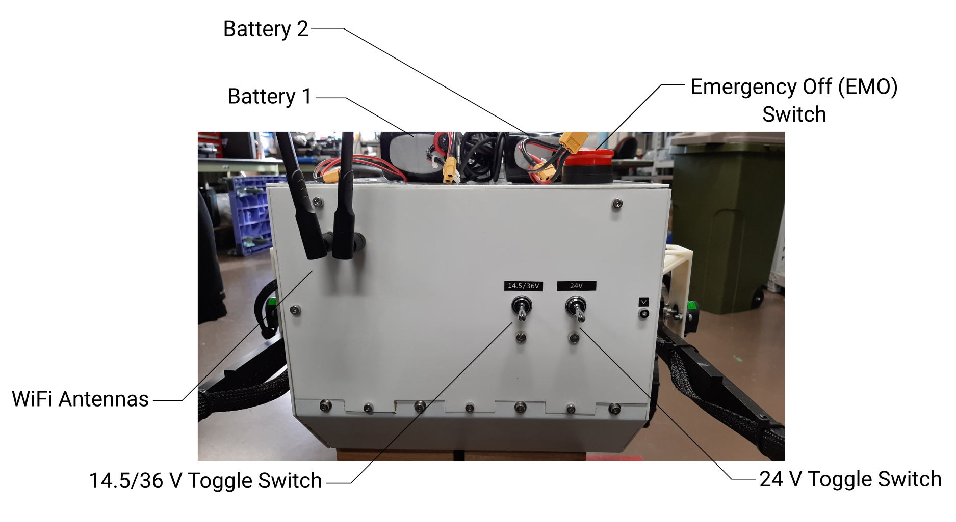

***Fig. 8-1.*** *Reference image of EX1 back panel.*

## Start-up sequence.

The following procedure describes how to start and operate the EX1 rover from the GCS Main Computer. The following procedure assumes that the rover has already been powered up as indicated in Section 8.1.

### Remote access to the P-OBC.

First step will be to connect the GCS to the P-OBC via Secure Shell (SSH). Make sure both the GCS Main Computer and the P-OBC share the same network.

#### Important Information

The current SSH configuration has been defined using a key-based authorization instead of a username-password based authorization method. The public key can be found under *authorized_keys* in the *~/.ssh* directory of the P-OBC.

The following information should be noted and kept private:

P-OBC Private IP Address: 10.240.20.170 (RANDOMWALK3_2.4GHz WLAN Network)

P-OBC Username: roverTX2

P-OBC Password: rovertx2

SSH Port: 2020

Public/private SSH Key Pair:

Key Comment: [davidrm@dc.tohoku.ac.jp](mailto:davidrm@dc.tohoku.ac.jp)

Key Passphrase: her0_EX1_r0ver

*Note: The private IP address of the P-OBC may change based on the network used. If the same network is to be used often, it is highly recommended to set up a static IP address for the P-OBC.*

To connect to the P-OBC, open the SSH client application called **PuTTY**. The necessary configuration has been already saved. Under Load, save or delete a stored session, load the following sesion*: EX1 Rover P-OBC SSH Auth 10.240.20.170.*

Make sure to change the IP address under *Hostname* if a new or different network is used. It is highly recommended to change and save the new session settings so as to avoid having to make changes every time a new connection is established.

*Note: The session called EX1 Rover P-OBC 10.240.20.170 is a backup of the initial SSH configuration under a username-password-based authorization. In the event that the Key Pair fails, load this configuration instead and proceed to connect with the P-OBC username and password as indicated above.*

Once the proper configuration has been defined, click Open and a new SSH connection will automatically start.

Input the *Key Passphrase* as previously defined and you will be finally connected to EX1 P-OBC.

### Waking up EX1

Since multiple virtual terminals are necessary to start up EX1, we need to use the Screen package functionality (see Learning Resources for more information).

Start a new screen session:

$ screen

Open a new virtual terminal by clicking Ctrl+a c. Note: Check all the Screen commands with Ctrl+a ?.

First, in the new virtual terminal run the following command in order to connect the PS4 Dualshock joystick.

$ sudo ds4drv

(input P-OBC user password if required)

Connect the joystick following the instructions in Section 8.3.

Next, switch to a different virtual terminal with Ctrl+a space and run the following set of commands to access superuser (root) mode:

$ sudo su

(input P-OBC user password if required)

We need to source the setup.bash file in the root environment by:

$ source HERO_EX1/devel/setup.bash

*Note: Superuser mode is required in order for the control signals sent when turning the lights on/off to properly work. Future students may look deeper into other ways to define how to access and control GPIO pins from the ROS environment without requiring root privileges. The solution presented here is meant to work but is not perfect.*

And finally start the rover up with:

$ roslaunch ex1_startup wake_up.launch

***Note: If we would like to record telemetry data, the command should be instead*** $ roslaunch ex1_startup wake_up.launch telemetry:=1

### Learning resources

Learn more about SSH:

1. <https://hostpresto.com/community/tutorials/how-to-connect-to-a-linux-server-using-secure-shell-ssh/>
2. <https://www.codeproject.com/Articles/497728/HowplustoplusUseplusSSHplustoplusAccessplusaplusLi>

Learn more about Screen Terminal-multiplexer.

1. <https://linuxize.com/post/how-to-use-linux-screen/>

## Connecting a PS4 Dualshock controller to the P-OBC.

### Preparation.

Make sure that PIP3 (python 3 package manager) is installed. *Note: the same would apply if you need pip for python 2. Just substitute pip3 for pip.*

$ pip3 --version

If pip3 is not installed, start by updating the package list using the following:

$ sudo apt update

$ sudo apt upgrade

Use the following command to install pip3:

$ sudo apt install python3-pip

All the dependencies will be also installed.

*Note: When installing python modules globally, it is highly recommended to install distribution-provided python modules using the apt package manager since they are tested to work properly on Ubuntu systems. You should install python modules globally using pip only if there is no package available through the package manager.*

### Installation

If not yet installed, make sure to install ds4drv, a Sony DualShock 4 userspace driver for linux (available at <http://github.com/chrippa/ds4drv>).

$ sudo pip3 install ds4drv

### Connection

#### Option 1: Connecting via bluetooth.

Run ds4drv.

$ sudo ds4drv

Hold SHARE and PS buttons in the PS4 controller until its indicator flashes. Ds4drv will automatically start searching for bluetooth devices and establish a connection.

Once ds4drv finds your controller, it will be assigned to /dev/input/js~.

#### Option 2: Connecting via USB.

Run ds4drv in hidraw mode.

$ sudo ds4drv --hidraw

Connect the PS4 controller via usb to the Jetson. Ds4drv will automatically start searching for bluetooth devices and establish a connection.

Once ds4drv finds your controller, it will be assigned to */dev/input/js~.*

### Testing

#### Option 1: Without ROS

Install and run jstest:

$ sudo apt-get install jstest-gtk

$ jstest-gtk

*Note: the -gtk option is only required if you want to see the output displayed on an independent GUI.*

#### Option 2: With ROS

First, make sure you have the joy package installed.

$ rospack find joy

If not installed, install the package. Note: make sure you use your own ROS distribution:

$ sudo apt install ros-melodic-joy

In a new terminal, launch ROS:

$ roscore

In a new terminal, tell the joy node which joystick device to use. Note: the default is js2.

$ rosparam set joy_node/dev “/dev/input/js~”

Start the joy node

$ rosrun joy joy_node

In a new terminal, run the following command to see the data published on the joy topic:

$ rostopic echo joy

### Reference.

#### DualShock PS4 Controller buttons and axes mapping

Table of index number of /joy.buttons:

***Table 8-1.*** *Index number of joy.buttons*

|  |  |
| --- | --- |
| Index | Button name on the controller |
| 0 | Square |
| 1 | Cross |
| 2 | Circle |
| 3 | Triangle |
| 4 | L1 |
| 5 | R1 |
| 6 | L2 |
| 7 | R2 |
| 8 | Share |
| 9 | Options |
| 10 | Left joystick press |
| 11 | Right joystick press |
| 12 | PS |
| 13 | Touchpad press |

Table of index number of /joy.axes:

***Table 8-2.*** *Index number of joy.axes.*

|  |  |
| --- | --- |
| Index | Axis name on the controller |
| 0 | Left/Right axis (left stick) |
| 1 | Up/Down axis (left stick) |
| 2 | Left/Right axis (right stick) |
| 3 | L2 |
| 4 | R2 |
| 5 | Up/Down axis (right stick) |
| 9 | Left/Right arrow buttons (+: left, -: right) |
| 10 | Up/Down arrow buttons (+: up, -: down) |
| Others | Accelerometers/Gyroscope |

### Troubleshooting

#### Running ds4drv without sudo permissions.

If you want to use ds4drv as a normal user, you need to make sure ds4drv has permission to use certain features of your system. Ds4drv uses the kernel module uinput to create input devices in userland and the module hidraw to communicate with DualShock 4 controller (when using --hidraw), but this usually requires root permissions.

You can change the permissions by copying the udev rules file to */etc/udev/rules.d* (called “*50-ds4drv.rules*”, check <https://github.com/chrippa/ds4drv/blob/master/udev/50-ds4drv.rules>):

File *50-ds4drv.rules* should contain the following lines

|  |  |
| --- | --- |
|  | KERNEL=="uinput", MODE="0666" |
|  | KERNEL=="hidraw*", SUBSYSTEM=="hidraw", ATTRS{idVendor}=="054c", ATTRS{idProduct}=="05c4", MODE="0666" |
|  | KERNEL=="hidraw*", SUBSYSTEM=="hidraw", KERNELS=="0005:054C:05C4.*", MODE="0666" |
|  | KERNEL=="hidraw*", SUBSYSTEM=="hidraw", ATTRS{idVendor}=="054c", ATTRS{idProduct}=="09cc", MODE="0666" |
|  | KERNEL=="hidraw*", SUBSYSTEM=="hidraw", KERNELS=="0005:054C:09CC.*", MODE="0666" |

You may have to reload your udev rules after this with:

$ sudo udevadm control --reload-rules

$ sudo udevadm trigger

#### Check if linux recognize your PS4 controller

Run the following command:

$ ls /dev/input

You will see a listing of all of your input devices. The joystick devices are referred to as js~.

#### PS4 controller is not accessible for the ROS joy node

First, list the permissions of the PS4 controller:

$ ls -l /dev/input/js0

You will see something similar to:

$ crw-rw-XX- 1 root dialout 188, 9 2019-11-01 12:04 /dev/input/js~

If XX is rw, the js device is configured properly. If XX is not rw, you need to run the following:

$ sudo chmod a+rw /dev/input/js~

#### Ds4drv hidraw mode not detecting your controller

This usually happens when the name associated with your controller is slightly different than the name defined in hidraw.py.

First, let’s check which names the controller has associated. Run the following command in a terminal. Make sure the controller is connected via USB.

$ dmesg

You will be able to read something like the following

[18798.634308] input: Sony Interactive Entertainment Wireless Controller as /devices/virtual/input/input21

Note: if this line does not appear in your terminal, make sure your controller is listed as one of the usb inputs. $ lsusb

In this case, the name associated with the device is “Sony Interactive Entertainment Wireless Controller”. Then, go to /usr/local/lib/python3.6/dist-packages/ds4drv/backends and open the file hidraw.py. Add the following line to the script (highlighted line only).

$ HID_DEVICES = {

“Sony Interactive Entertainment Wireless Controller”: HidrawUSBDS4Device

“Sony Computer Entertainment Wireless Controller”: HidrawUSBDS4Device

“Wireless Controller”: HidrawBluetoothDS4Device}

## Accessing the P-OBC GPIO pins.

### Basic information.

There are many ways to access GPIO hardware from programs. Linux kernel uses a sysfs interface for basic GPIO control. Sysfs is a pseudo filesystem provided by the linux kernel that makes information about various kernel subsystems, hardware devices, and device drivers available in user space through virtual files. GPIO devices appear as part of sysfs.

As indicated in Section 4.4., EX1 rover LCB is defined in the following way:

* ON : 0 V (low)
* OFF: > 2.9 V (high)

The following pins from the P-OBC J21 Header Pinout are used for the LCB.

***Table 8-3****. P-OBC GPIO reference for controlling the lights.*

|  |  |  |  |
| --- | --- | --- | --- |
| Function in LCB P-OBC CTRL | P-OBC Pin | Connector Label | Sysfs GPIO Ref. |
| GND (Pin 1) | 39 | GND | n.a. |
| ON/OFF LEDs right eye (Pin 2) | 37 | GPIO26 (3.3V) | gpio388 |
| ON/OFF LEDs left eye (Pin 3) | 35 | GPIO19 | gpio395 |
| ON/OFF LED Bar (Pin 4) | 33 | GPIO13 | gpio389 |

### Quick testing of GPIO pins from userspace.

The following instructions describe how to manually activate and control the output of the GPIO pins. First of all, open a new terminal and enter root user mode.

$ sudo su

In root mode, go to the following directory:

$ cd /sys/class/gpio

If you were to check the contents of this directory, you will notice folders with names such as gpiochip216. These gpiochip directories are device names for the GPIO controllers and we won’t use them directly.

First thing we need to do to activate certain pins is to export them using the following command:

$ echo sysfs_gpio_number > export

Make sure to substitute sysfs_gpio_number for the GPIO number of the pin you would like to activate. For instance, if we would like to activate pin 37 (i.e., gpio388 in sysfs) in the J21 pinout of the P-OBC, the command would be:

$ echo 388 > export

Once exported, a new folder called gpio388 was created inside the gpio directory. From this new folder, we will be able to read and modify the functionality and properties of this GPIO pin.

Two properties are relevant to us: direction (in or out) and value (high or low, 1 or 0).

To read them use the following command within the general gpio directory:

$ cat gpio388/direction

$ cat gpio388/value

To modify its properties, use the following command:

$ echo out > gpio388/direction

$ echo 1 > gpio388/value

Once you are done testing unexport the pin:

$ echo 388 > unexport

And exit root mode:

$ exit

*Notes: In the actual code used to operate EX1, we used a C++ library containing functions that call the export, direction, and value operations of the sysfs interface. The header file can be found under the /src/ folder of the teleop package.*

## Sending data through P-OBC USB port using ROS serial library.

### Preparation.

Connect the device to the USB port or USB Hub port on the P-OBC. We need to know what the /dev path to the usb has been assigned. Note: usually it will be assigned to /dev/ttyUSB0.

There are many ways to do this. A simple way is to create and run the following bash shell file.

#!/bin/bash

#Simple file to find the dev path of peripherals.

for sysdevpath in $(find /sys/bus/usb/devices/usb*/ -name dev); do

(

syspath="${sysdevpath%/dev}"

devname="$(udevadm info -q name -p $syspath)"

[[ "$devname" == "bus/"* ]] && continue

eval "$(udevadm info -q property --export -p $syspath)"

[[ -z "$ID_SERIAL" ]] && continue

echo "/dev/$devname - $ID_SERIAL"

)

Save this file as find_dev.sh and run it.

$ bash find_dev.sh

Next thing we need to do is to install a serial port library called serial.

*Note: change melodic for whatever ROS distribution you are using. Documentation about the serial library can be found in* [*http://wjwwood.io/serial/doc/1.1.0/index.html*](http://wjwwood.io/serial/doc/1.1.0/index.html)

$ sudo apt install ros-melodic-serial

### Operation

The following is an example code used to send a single byte through USB.

// send_byte.cpp program

#include <ros/ros.h>

#include <serial/serial.h>

#include <stdio.h>

#include <string>

#include <sstream>

#include <time.h>

#include <stdlib.h>

std::string port = "/dev/ttyUSB0"; //Include here the dev path of your USB device!!

uint32_t baud = 115200; //setup baud

serial::Serial serial(port, baud, serial::Timeout::simpleTimeout(200));

int main(int argc, char** argv)

{

char cmd;

ros::init(argc, argv, "send_byte"); // ノードの宣言

while(ros::ok())

{

ros::spinOnce();

std::cout << "cmd >> ";

std::cin >> cmd;

serial.write((uint8_t*)(&cmd), 1); // データを送信する

ROS_INFO("%s", &cmd); // デバッグ用

}

return 0;

}

Make sure the variable *port* contains the right */dev* path. After declaring all dependencies and executable files and building the workspace, we need to assign to the USB port the right permissions to write and read. Run the following command.

*Note: make sure you use your own* dev *path.*

$ sudo chmod a+rwx /dev/ttyUSB0

Finally, run roscore and the send_byte node. One byte will be sent through every time you input a character into the command line.

$ cmd >> A

## Mounting/dismounting chassis panels.

In order to mount EX1 chassis panels always follow this procedure:

1. Start by mounting the side panels.
   1. Attached the rocker sensor support structure to the side panel.
   2. Pass all the cables through the support structure first and then through the center hole in the panel.
   3. Mount the panel to the chassis.
   4. Connect cables to the Rocker Interface Unit (RIU). You may help yourself with a pair of tweezers.
2. Next, pick up the top panel and without fully attaching it to the chassis, connect the EMO switch and the battery connectors.
3. Without tightening any of the screws that attach the top panel to the chassis, attach the NAVMAST to the top panel and pass all the cables through the front side opening. Connect the cables to their respective boards.
4. Bring the front panel closer to the chassis so that the LED Bar cable can be also passed through and connected to the LCB. Do not screw the front panel to the chassis yet. Leave the front panel placed somewhere securely.
5. Next, tighten the nuts of the front and back screws of the top panel.
6. Fasten the screws of the front panel.
7. Connect the switches on the back panel to their respective connectors as well as both red LED lights to the PSU.
8. Last, fasten the screws of the back panel to the chassis.

*NOTE: For the dismounting operation simply follow the previous steps in the reverse order.*

**Important!** Make sure not to attempt to loosen or tighten the screws marked with the symbol shown in Fig. 8-2. These screws are “fake”. Fake screws were glued to the chassis panels as a result of the impossibility to tighten them (the chassis frame was not properly threaded and post-assembly insertion nuts sold by MISUMI for this specific aluminum extrusion frame are currently discontinued).



***Fig. 8-2.*** *Fake screw sign.*

## Low-Travel Suspension and wheel assembly process.

The following step-by-step guide describes the best procedure to assemble and disassemble the LTS subsystem of the EX1 rover.

#### Wheel

1. Get the wheel front face (see (1) in Fig. 8-3 for reference) mounted onto the wheel rim. [ 12 x M3x10 screws] (*NOTE: Make sure not to use a very high torque when fastening and loosening screws in order not to detach the nuts from the inside of the rim.*)
2. Attach the small metal key holder (Fig. 8-3 (2)) to the front face of the wheel. [ 4 x M3x10, 4x M3 Nuts].
3. Attach the bearing (Fig. 8-3 (3)) to the back face of the wheel (Fig. 8-3 (4)). [ Hammer needed] (*NOTE: Make sure both the back face of the wheel outer surface and the bearing outer plane are flat.*)
4. Attach the motor housing (Fig. 8-3 (5)) to the wheel knuckle (Fig. 8-4 (7)). [ Hammer may be needed, 6 x M3x12] (*NOTE: Make sure to tighten the safety nut at the other end of the housing. Make sure to use threadlocker on screws.*)
5. Attach the back face of the wheel with the bearing to the motor housing. [ Hammer needed] (*NOTE: Make sure you only hit the metal parts of the bearing with the hammer in order not to damage the plastic parts of the wheel.*)
6. Attach the driving motor (Fig. 8-3 (6)) into the housing. [6 x M3x8] (*NOTE: Make sure motor cables are pointing up or slightly to one side to facilitate wiring afterwards*.)
7. Attach the front face and rim of the wheel (Fig. 8-3 (7)) to its back face. [12 x M3x10] (*NOTE: Make sure not to use a very high torque when fastening and loosening screws in order not to detach the nuts from the inside of the rim.*)

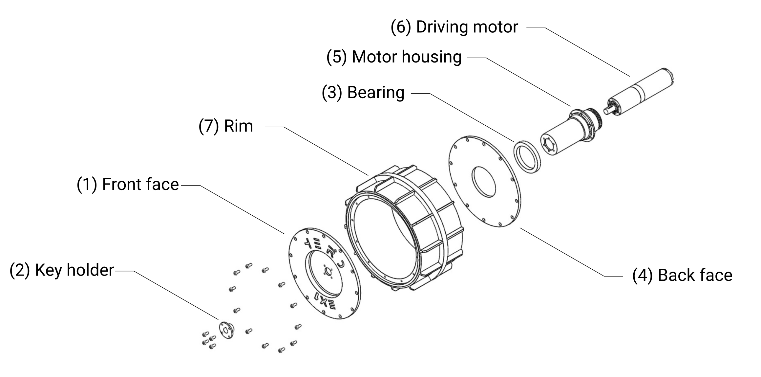

***Fig. 8-3.*** *EX1 wheel exploded view.*

#### Low-travel suspension

1. Assembly the L-shaped bracket (Fig. 8-4 (1)) of the low-travel suspension, i.e., the top part that connects to the geardhead of the steering motor (Fig. 8-4 (2)) and the attachment part for the shock absorbers (Fig. 8-4 (3)) and the upper and lower control arms (Fig. 8-4 (4) and (5), respectively).
2. Add one single retainer to all the shafts (Fig. 8-4 (6)).
3. Mount both upper and lower control arms to the L-shaped part of the suspension. (*NOTE: To add the retainers make sure you always press downwards (take advantage of gravity) and the best tool to use is a hammer with a rubber head. Do not hit the retainer but press against it.*).
4. Connect upper and lower control arms to the wheel knuckle (Fig. 8-4 (7)).
5. Attach the two shock absorbers to the L-shaped part of the suspension and the wheel knuckle. [4x M3x18/15] (*NOTE: Recommended to first attach shocks to L-shaped part.*)
6. Pre-load the springs.

#### Integration on the chassis

1. Mount steering motor holder (i.e., part that connects the low-travel suspension to the rocker)(Fig. 8-4 (8)) onto the rocker. [2 x M4x30]
2. Attach the low-travel suspension to the steering motor gear head. [ 4 x M3x12]
3. Attach the whole assembly to the motor holder. [2 x M3x25, 2 x M3 Nuts, 2x M3x18].

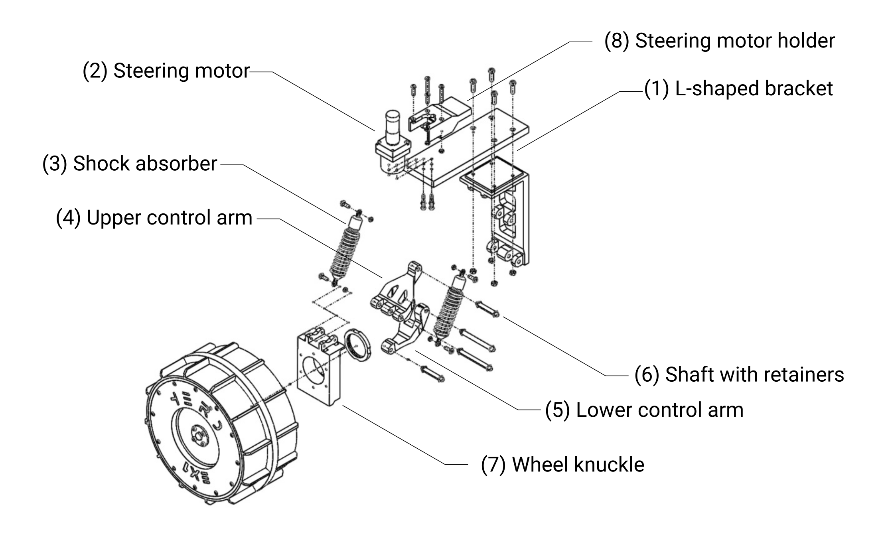

***Fig. 8-4.*** *EX1 Low-travel suspension (LTS) exploded view.*

## EX1 Teleoperation

The following table describes the different button combinations currently supported by EX1 functionality. A visual reference is provided in Fig. 8-5.

***Table 8-3.*** *EX1 Joystick button combination.*

|  |  |
| --- | --- |
| Functionality | Button combination |
| Drive forward | Left joystick UP |
| Drive backward | Left joystick DOWN |
| Steer left | Right joystick LEFT |
| Steer right | Right joystick RIGHT |
| Max. driving speed selection | L1 |
| Point-turn-mode ON/OFF | Triangle + R1 |
| Point-turn left | L2 (full throttle) |
| Point-turn right | R2 (full throttle) |
| Lights ON/OFF | Cross |

**Important notes** regarding teleoperation:

* Maximum driving speed selection loops from 0.1 to 1 m/s in steps of 0.1 m/s. Initially speed is dissable as a safety measure. L1 has to be pressed once before the rover can initiate movement.
* When point-turn mode is active, normal driving and steering capabilities are dissabled.
* Point-turn is currently performed at a fixed speed of 0.2 m/s limited by software. This limit can be changed at any given time from the P-OBC main OS.

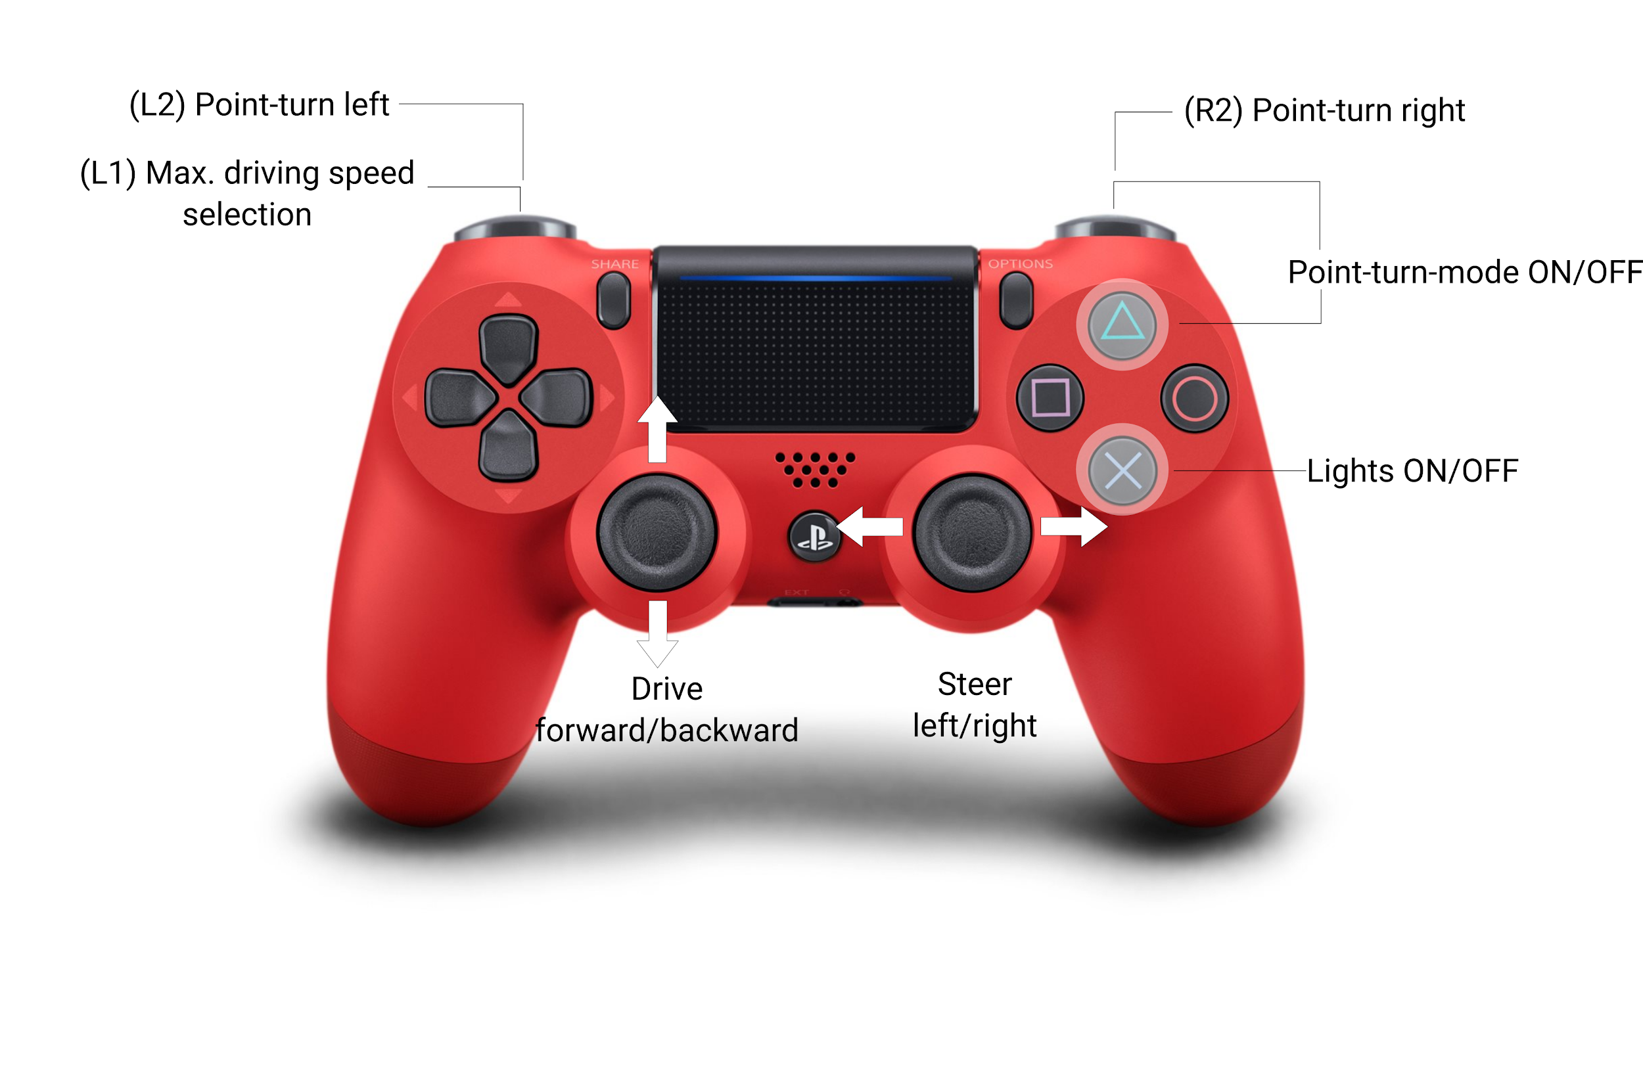

***Fig. 8-5.*** *EX1 joystick reference for teleoperation.*

# Appendix A - Modifications Log.

|  |  |  |  |  |  |  |
| --- | --- | --- | --- | --- | --- | --- |
| **ID:** | #*0_example* | | **Name:** | David Rodriguez | **Date:** | 2019/5/12 |
| **Affected Systems:** | | * Locomotion | | **Affected Subsystems:** | * Low-travel suspension. * Drive electronics. | |
| **Brief description:** | | * Drive motors have been upgraded for better performance. * Speed commands limits have been adjusted at the low-level. * Low-level control software has been updated. New code has been pushed to the repository *ex1_low_level*. | | | | |
| **Further information was included in the following sections:** | | | | * Chapter 4. Section 1. * Chapter 6. Section 3 & 4. | | |

# Appendix B - UART reading with Matlab.

In order to debug the transmission of data without interruptions, an extra FTDI UART serial port can be used to send data to the Ground Control Station (GCS) while the communication link with the Primary-OnBoard Computer (P-OBC) is still active. For this, a MATLAB script was developed to store and process the raw data being transmitted. An example of how this script can be used includes the location of a specific problem while tuning the automatic control loop. All the relevant control variables can be stored by the script and plot afterwards, making the tuning process much easier.

The script is presented below and was last used on MATLAB 2019b.

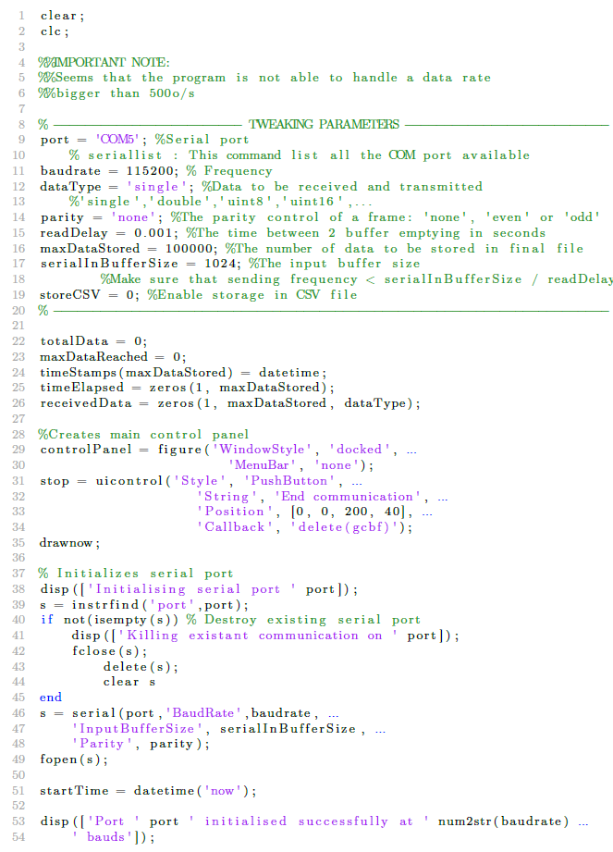

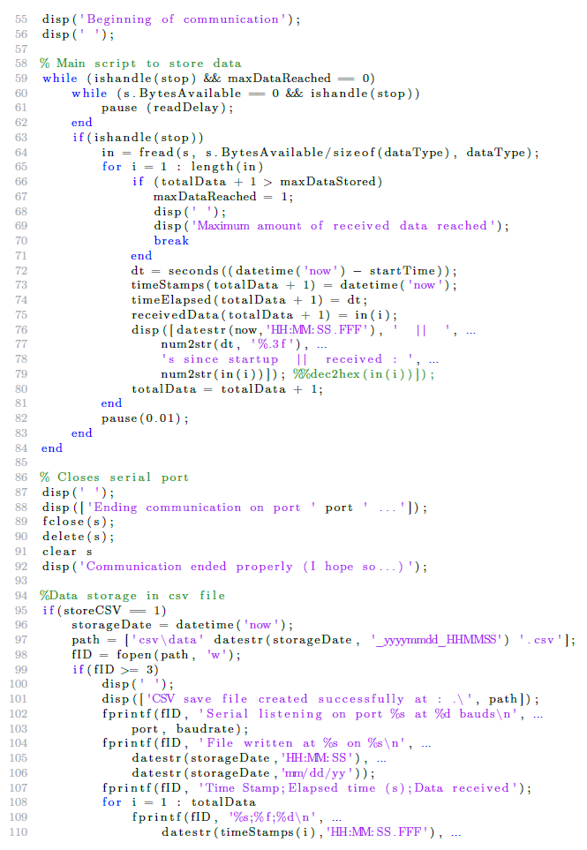

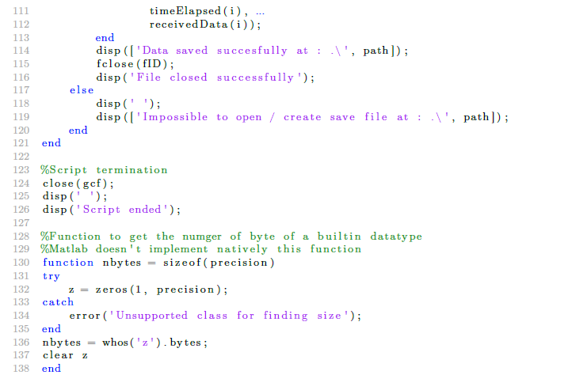

# Appendix C - WARN & ERROR Reference.

Note:

* The following provides a list of warnings and errors potentially displayed by the high-level control software.
* This list is meant as a reference and a tool to help future users identify the source of unwanted behaviors and keep track of potential changes in the error management system.

#### ROS_WARN_STREAM

*Warning # | Definition | File where this error is define | Suggested action*

1 | “No match for wheel_id” | teleop/src/*ex1_teleop.cpp*  | Wheel node ID parameter does not correspond to any of the switch cases. Check *teleop.launch* file.

2 | “No rocker_id found” | teleop/src/*ex1_teleop.cpp* | Rocker ID parameter has not been defined. Check *teleop.launch* file.

3 | “Unsuccessful packet: Packet size larger than MAX_PACKET_SIZE” | ex1_serial/src/*detect_pkt.cpp* | Check MAX_PACKET_SIZE definition in config file *internal_comms.xml*.

4 | “Unsuccessful packet: Previous packet ended prematurely.” | ex1_serial/src/*detect_pkt.cpp* | n.a.

5 | “Unsuccessful packet: Packet size is smaller than MIN_PACKET_SIZE” | ex1_serial/src/*detect_pkt.cpp*  | Check MIN_PACKET_SIZE definition in config file *internal_comms.xml*.

6 | “Unsuccessful packet: CMD is not in the list of commands” | ex1_serial/src/*pkt_validation.cpp* | Check teleop/config/*cmd_map.yaml* file.

7 | “Unsuccessful packet: LEN doesn't match with the corresponding CMD id value.” | ex1_serial/src/*pkt_validation.cpp* | Check teleop/config/*cmd_map.yaml* file.

8 | “Unsuccessful packet: LEN doesn't match with the packet size.” | ex1_serial/src/*pkt_validation.cpp* | Check teleop/config/*cmd_map.yaml* file.

9 | “Unsuccessful packet: CRC validation doesn't match with the corresponding CRC value. | ex1_serial/src/*pkt_validation.cpp* | Check teleop/config/*cmd_map.yaml* file.

#### ROS_ERROR_STREAM

*Error # | Definition | File where this error is define | potential solution*

1 | “Unable to open port” | ex1_serial/src/*serial_Tx_Rx.cpp*  | USB ports for Motor Controllers are not correctly defined in config file *internal_comms.xml*.

# Appendix D - Datasheets.

# 

## 

1. Visual-based teleoperation implies that the pilot is capable of maintaining sight of the rover at all times as opposed to instrument-based teleoperation in which the pilot relies exclusively on the output from proprio and exteroceptive sensors to operate the rover; e.g. teleoperation based on real-time video feed from the navigation cameras. Mixed-teleoperation would refer to a combination of both visual and instrument-based teleoperation.
2. JetPack provides the Jetson Developer Kit with the latest OS image, libraries and APIs, samples, and documentation, as well as developer tools.
3. https://www.eclipse.org/downloads/packages/release/2019-12/r/eclipse-ide-cc-developers
4. https://www.hibot.co.jp/uploads/ecommerce/products-files/9f8dd17aa0aaef4688a6a9e874bb1d4a.pdf
5. https://github.com/theolind/mahm3lib/wiki/Integrating-Doxygen-with-Eclipse
6. A rosbag or bag is a file format in ROS for storing ROS message data. These bags are often created by subscribing to one or more ROS topics, and storing the received message data in an efficient file structure
7. efficiency= No. of useful bits/Total bits = 8 data bits/(8 data bits + 1 stop bit + 1 start bit)
8. Max. baud rate = efficiency x baud rate
9. http://www.stuartcheshire.org/papers/COBSforToN.pdf
10. In the original COBS algorithm, only one single 0x00 bytes is added at the end. In our case we decided to also add one at the beginning to facilitate the detection of a starting transmission.
11. Max rate = max baud rate / SUM of stuffed size of packets = 92,160/101.